SharePoint Workflow

# Introduction to Workflow:

Workflows can also be used to automate many recurrent tasks that your team performs on a regular basis, ensuring consistency and saving a lot of time and manual tasks.

A SharePoint workflow is basically an automated flowchart that specifies what happens at each step of a process. Approval workflow automatically runs the process for you. It checks, tracks, reminds and forwards the document to the right people at the right time. If someone forgets to complete a task or doesn’t finish on time, the workflow will notify.

Workflows in SharePoint 2013 allow you to model and automate business processes. These business processes can be as simple as a document approval process with a single approver.

SharePoint 2013 workflows are powered by Windows Workflow Foundation 4. Windows Workflow Foundation 4 workflows are a structured collection of workflow "activities," each of which represents a functional component of a business process. The workflow platform in SharePoint 2013 uses the Windows Workflow Foundation 4 activity model to represent a SharePoint-based business process. Also workflows now entirely declarative (that is, designer-based, no-code workflows).

Two components are there, workflow activities and SharePoint actions. Workflow activities represent the underlying managed objects whose methods drive workflow behaviours. Workflow actions, on the other hand, are wrappers that encapsulate the underlying activities and present them in a user-friendly form in SharePoint Designer.

SharePoint Server 2013 can use a new workflow service built on the Windows Workflow Foundation components of the .NET Framework 4.5. This new service is called Workflow Manager.

The activities, which are implementations of activity classes, are implemented declaratively by using XAML.

Workflow activities are invoked using loosely coupled web services that use messaging APIs to communicate with SharePoint. These APIs are built on the messaging functionality that is provided by Windows Communication Foundation (WCF).

In SharePoint 2013 farm, Windows Workflow Foundation and WCF are hosted in Workflow Manager Client 1.0.

## Workflow Manager Client 1.0 :

It provides the management of workflow definitions. It also hosts the execution processes for workflow instances.

## SharePoint 2013:

It provides the framework for SharePoint workflows, which model SharePoint-based business processes that involve SharePoint documents, lists, users, and tasks. Additionally, SharePoint workflows, associations, activities, and other workflow metadata are stored and managed in SharePoint 2013.

## SharePoint Designer 2013:

It is the primary business-user tool for creating workflow definitions and publishing them.

SharePoint Designer 2013 is the authoring tool of choice for SharePoint workflows. Although some advanced tasks (like creating custom actions, for example) require the intervention of a developer using Visual Studio, SharePoint Designer 2013 provides the most flexible access to workflow development to the widest range of workflow authors.

## SharePoint Workflow Platforms:

The SharePoint 2010 Workflow platform has been carried forward to SharePoint Server 2013. All of your workflows that were built by using SharePoint Server 2010 will continue to work in SharePoint Server 2013.

In SharePoint Server 2010 the workflow engine installed automatically with the product. This continues to be the case with the SharePoint 2010 Workflow platform in SharePoint Server 2013. If you simply install SharePoint Server 2013 and do not install and configure Workflow Manager then you will have a nearly identical experience with building workflows as you did in SharePoint Server 2010.

The SharePoint 2013 Workflow platform only becomes available to you, and your tools, after you download and install the new Workflow Manager Service and configure it to communicate with your SharePoint Server 2013 farm.

## Workflow Manager:

Workflow Manager 1.0 provides the capability to host workflows in a high scale, high density, and multi-tenant environment. Workflows are authored using a fully declarative model, using Microsoft .NET Framework 4.5 and Windows Workflow Foundation (WF45). SPWorkflowManager is the only object that developers can use to interact with the SharePoint workflow runtime.

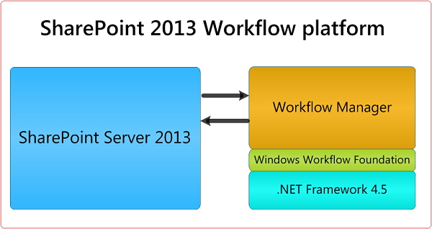

## Steps to install and configure workflow manager in SharePoint 2016/SharePoint 2013.

Follow below article to configure workflow manager.

Configure workflow manager SharePoint 2016 workflow in windows server 2012 r2 <https://www.enjoysharepoint.com/configure-workflow-manager-sharepoint-2016-workflow-in-windows-server-2012-r2/>

# Basic Building Blocks of Workflows:

## Initiate a Workflow:

Initation means how you can start the workflow.

**On Creation:** The workﬂow is started only once, when a new item is created.

**On Change:** The workﬂow is started each time an item is edited.

**Manual:** The workﬂow is started manually. A user has to click on a Start button to start the workflow. The out-of-the-box workﬂows specify that the user who manually starts the workﬂow must have Edit Item permissions.

**Information Management Policies:**

When workﬂows are associated with content types, you can set up information management policies at the site or library content type level. When you define a retention policy, you can set it to initiate a workﬂow relative to a date column.

Example: You can start a workﬂow every 30 days.

## Initiation Forms:

When a workﬂow is set up to be started manually, it uses an initiation form. The person who makes the workﬂow can create predefined fields to be filled out by the person who manually starts the workﬂow (the initiator). When workﬂows are automatically initiated on creation or on change, there is no prompt to fill out a form.

## Steps:

Steps in a workﬂow define the order in which processes are supposed to happen. Each step can contain conditions and actions.

## Stages:

SharePoint 2013 provides a new action known as "Go to a stage". Rather than going from top to button, you can now go to a specific stage from one stage.

## Conditions and Actions:

Conditions can be thought of as rules. According to conditions that are set up, specified actions take place.

## Loops:

Loops allow the workﬂow to run a certain set of conditions and/or actions over and over again. You can add a loop and set it to run a specific number of times, or you can set a loop to run repeatedly while a certain condition exists.

## Associate a Workflow:

Whenever you create a workflow, you have to associate it to something in SharePoint. That can be a list, library, content type or even a site.

- When a workflow is associated to a specific content like a list or library then it is called as a list workflow.

- Another type of workflow known as site workflow which are usually initiated manually.

- Reusable workﬂows: Similar to site workﬂows, these types of workﬂows are not bound to any specific list when they are initially created. Reusable workﬂows are created to be used multiple times and can be reused on different sites. These workﬂows can be connected to different lists and libraries. When you create a reusable workﬂow in SharePoint Designer, you have an option to pick a base content type to limit the workﬂow to.

## Default Workflow:

By default there are few workflows presented in SharePoint like:

**Approval:**

An Approval workflow routes a document or other item to designated people for their approval or rejection.

**Collect Feedback:**

A Collect Feedback workflow routes a document or other item to designated people for their feedback.

**Collect Signatures:**

The Collect Signatures workflow routes a Microsoft Office document to designated people for their digital signatures. Note that the Collect Signatures workflow functions only with Word documents, Excel workbooks, and InfoPath forms.

**Three-State:**

The Three-state workflow is designed to track the status of a list item through three states (phases). It can be used to manage business processes that require organizations to track a high volume of issues or items.

With each transition between states, the workflow assigns a task to a person and sends that person an e-mail alert about the task. When this task is completed, the workflow updates the status of the item and progresses to the next state. The Three-state workflow is designed to work with the Issue Tracking list template, but it can be used with any list that contains a Choice column that has three or more values.

**Publishing Approval:**

A publishing approval workflow is similar to other SharePoint workflows in that it automates the routing of content to subject matter experts and stakeholders for review and approval. This workflows are designed specifically for publishing sites where the publishing of new and updated web pages is tightly controlled.

By default, the Approval, Collect Feedback, and Collect Signature workflows are not activated and are not listed in the Select a workflow template list box of the association form. To make them available for use, a site administrator must activate them at the site collection level.

**Example Three State Workflow:**

The Three-state workflow supports business processes that require organizations to track the status of an issue or item through three states and two transitions between the states. With each transition between states, the workflow assigns a task to a person and sends that person an email alert about the task. When this task is completed, the workflow updates the status of the item and progresses to the next state. The Three-state workflow works with the Issue Tracking list template. However, it can be used with any list that is set up to contain a Choice column with three or more values. The values in this Choice column serve as the states that the workflow tracks.

A list can have more than one choice column and the choice column can have more than three values. However, the Three-state workflow can only be configured to use one of the choice columns and only three of the values in the selected choice column. When you add a Three-state workflow to a list or library, you select a choice column and three of the values provide by the column.

When the workflow starts, it creates a task for the designated person. When a team member receives a task, he or she performs the work that is required to complete the task. The team member marks his or her workflow task as completed. At this point, the workflow updates the status of the event task in the issue-tracking list from Active to Ready for Review, and it creates a second task for the event coordinator to review the catering plan. After the event coordinator reviews and approves the catering plan, she marks her workflow task as complete, and the workflow updates the status of the task from Ready for Review to Complete.

For this demo first we will create a new SharePoint issue tracking list.

Settings icon -> Add an App. Choose Issue Tracking template. Then in the Create dialog box, give a name for the list.

Once the list got created successfully, it will be available in Site Contents page.

Click on the list to open the list. From ribbon LIST tab -> List Settings. Then under "Permissions and Management" click on "Workflow Settings". Then click on Add a workflow like below:

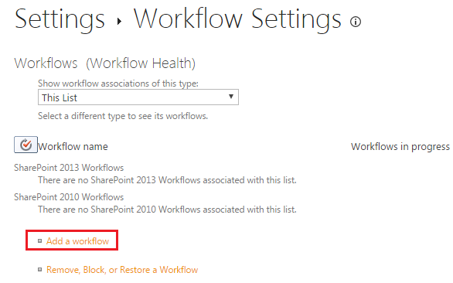

Then from the workflow choose Three-State.

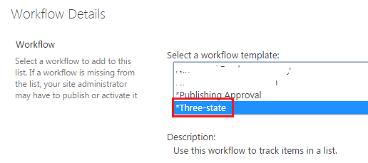

Then give a unique name, Task List, History List. And select the Start option how you want to start the workflow.

* Allow this workflow to be manually started by an authenticated user with Edit Item permissions. Require Manage Lists Permissions to start the workflow.
* Start this workflow to approve publishing a major version of an item.
* Creating a new item will start this workflow.
* Changing an item will start this workflow.

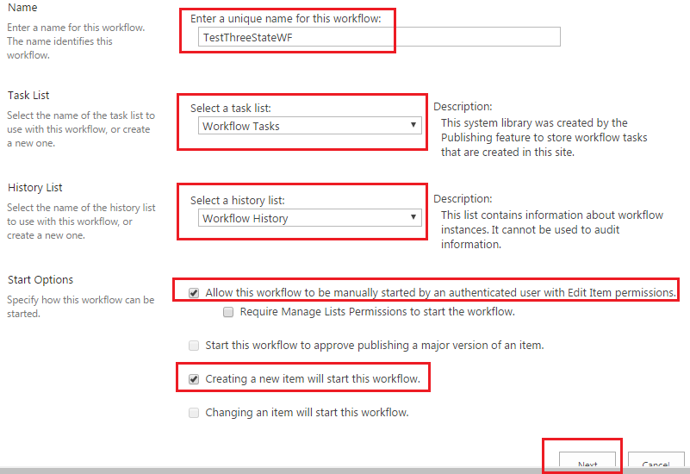

In the Customize the Three-state workflow page, You can customize the different status.

You can see more: <https://support.office.com/en-us/article/Use-a-Three-state-workflow-2bcc1a67-c282-40f5-ac49-915fc08b7e94>

Three State Workflow in SharePoint with Example <https://www.sharepointsky.com/three-state-workflow-in-sharepoint-with-example/>

Approval Workflow in SharePoint Online with example <https://www.sharepointsky.com/approval-workflow-sharepoint/>

SharePoint workflow examples: Collect Feedback Workflow <https://www.sharepointsky.com/collect-feedback-workflow/>

## Few features of SharePoint 2013 designer workflow:

- Web Service Call: Now you can call web services right from a workflow. You can pull in data from third-party external websites that may not be running SharePoint, and work with the data on your SharePoint intranet site.

- You can loop through in SharePoint designer 2013 workflow.

- New stages are there, which can be used to organize relates set of actions.

- You can now pause a workflow for specific duration.

- Visual Designer: Previously we used to create text based workflows, now you can do using visual designer.

## New Workflow Actions:

Below are few workflow actions has been added to SharePoint designer workflow.

- Assign a Task

- Start a Task Process

- Go to This Stage

- Call HTTP Web Service

- Start a List Workflow

- Trim String

- Find Substring in String etc.

You can check the full lists here: https://msdn.microsoft.com/en-us/library/office/jj163177.aspx

## Workflow actions deprecated in SharePoint 2013:

There are few workflow actions which are deprecated in SharePoint 2013.

- Add List Item Permissions

- Copy List Item

- Assign a To-do Item

- Remove List Item Permissions

- Replace List Item Permissions

- Start Custom Task Process etc.

- Impersonation block

- If current item field equals value

- Check list item permission levels

- Check list item permissions

Check out below msdn article for more reference:

<https://msdn.microsoft.com/en-us/library/office/jj163929.aspx>

# How to Start with SharePoint Designer Workflow?

Here we will see how we can create a simple SharePoint 2013 designer workflow. I am using my Office 365 site to design my workflow.

Open SharePoint 2013 designer -> then click on Open Site button from the home page.

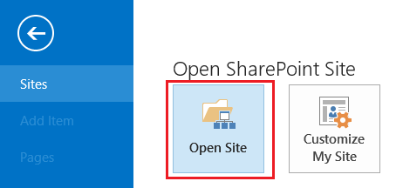

Then enter the url of the site and then click on Open site. This will open the site in the designer. If it will ask you to put credentials, kindly put the credentials.

Here I have a TrainingRequests list is presented in the site. In this list first we will add few columns in it using our designer.

From Navigation click on Lists and Libraries then in the List choose the list on which you want to add columns.

Then in the Customization Section click on Edit list columns. Here you can rename the default columns from Title to FullName. After that we add few columns like below:

Contact Number – Single line of text

Email ID – Single Line of text

Course Interested – Choice columns . It contains values like SharePoint 2016, SharePoint 2013, Office 365, SharePoint Online

Comments: Multiline of text

The list should looks like below:

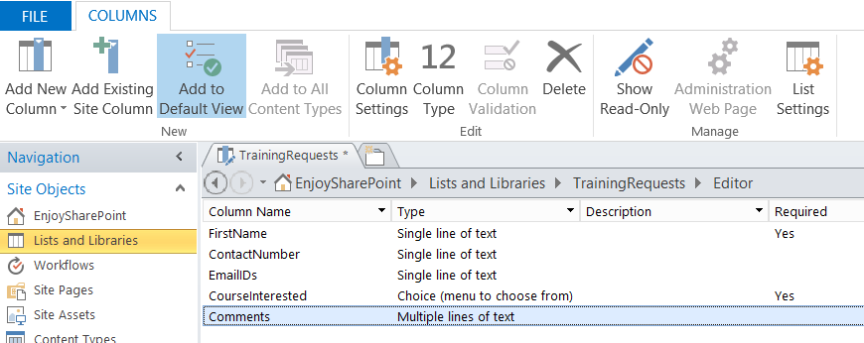

Now our list is ready we can create a workflow.

Then from the Navigation click on Workflows, then from the ribbon click on List Workflow and choose the list for which you want to create the workflow. Here we will choose our TrainingRequest list.

Then it will open the Create List Workflow dialog box.

Give a name for the workflow, give a description and then choose the workflow platform type as SharePoint 2013 Workflow.

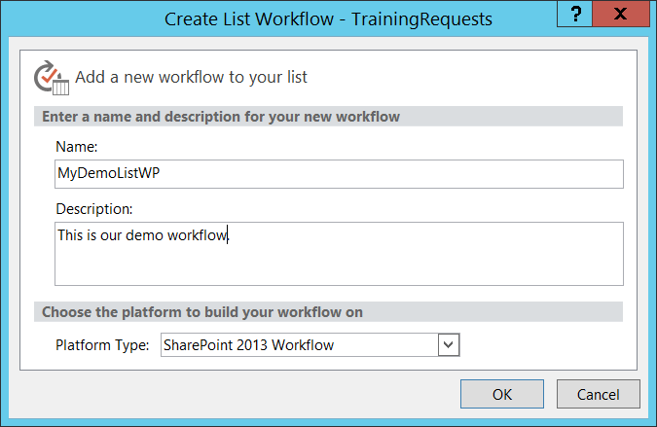

Click on OK to create the workflow.

Then it will open the workflow designer page.

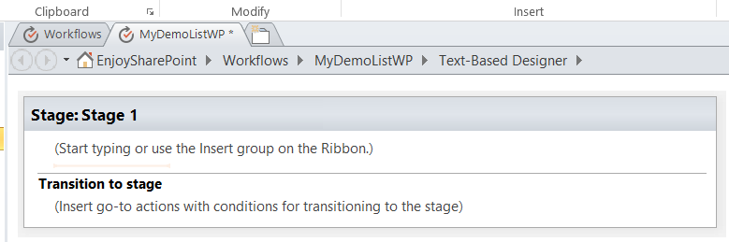

You can rename the stage by clicking on the rename.

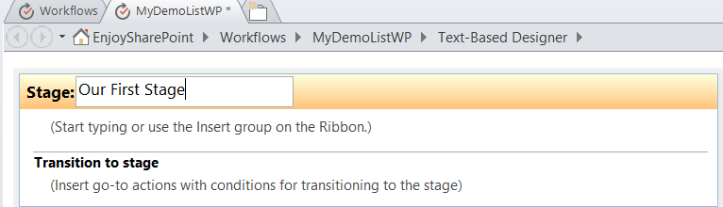

We can insert action now to the stage, you can click on the Start typing or you can insert from the Action menu.

Here we will add a Log to History action which will log information to the History List.

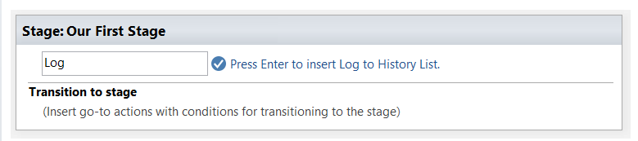

Or you can insert from ribbon.

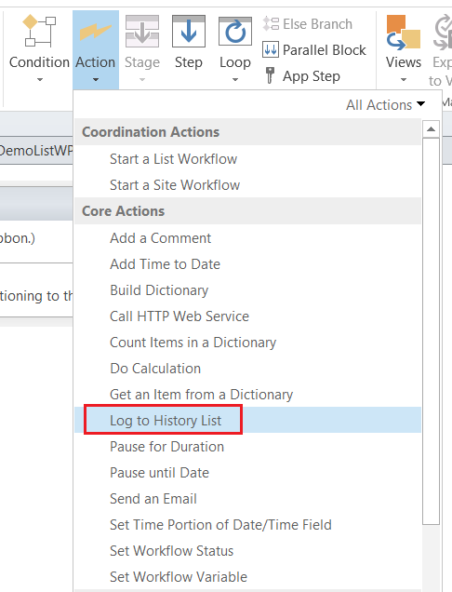

Action -> Log to History List as shown in the fig below:

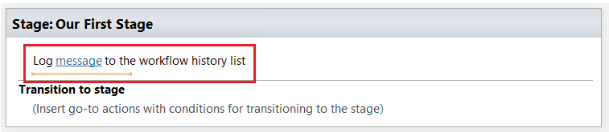

Then you can click on message to write what ever you want which will be save to the workflow list.

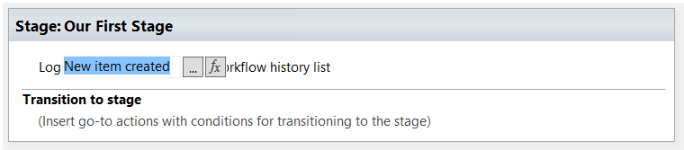

Any time if you want you can Save the workflow so that the changes will not lost. The workflow will not available unless and until you publish it. It will just Save the workflow.

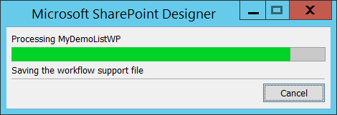

Now we go to the workflow settings page.

Go to the workflow Home page, you can see various important section like below:

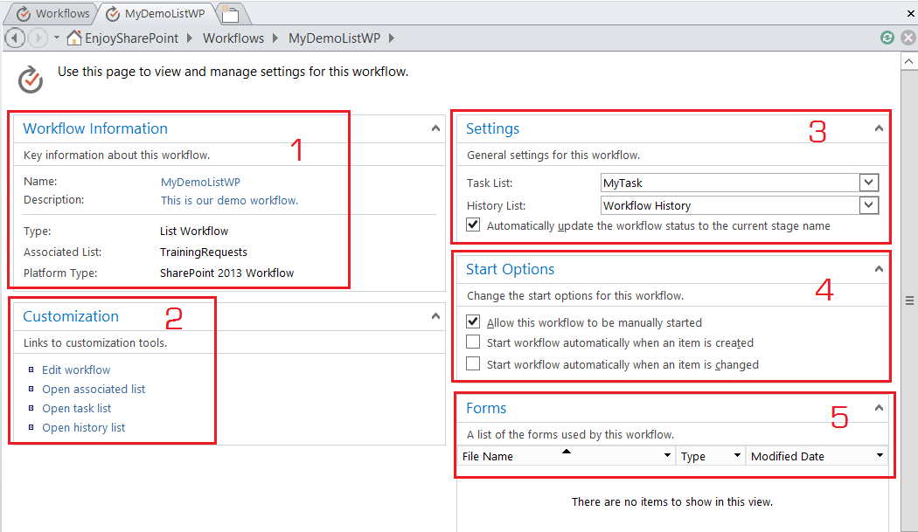

1. Workflow Information: This represents information like Name of the workflow, description, Type, Associated list and the workflow platform type.
2. Customization: Here there are various links like you can click on “Edit workflow” link to edit the workflow. You can also open the associated list, workflow history list and task list.
3. This will display the Task List and History List in the Settings section. You can set your own Task list and History List.
4. Start Option: This is important, it displays the options how you can start the workflow. There are 3 different ways you can start a workflow.

* You can start the workflow manually.
* You can start the workflow when an item is created
* You can start the workflow when an item is updated.

1. It displays the forms used.

Then you can click on the Check errors button to check if there is any errors presented in the workflow.

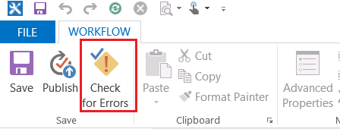

Now if you will check for errors it will display an error box. Because we have not added anything in the Transition to state.

There write Go to End of Workflow.

Now the workflow should looks like below:

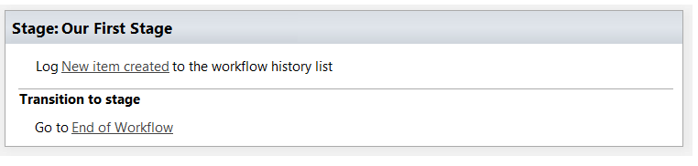

Now if you check for error, this time you will not receive any error.

After this you can Publish the workflow by clicking on the Publish button from the ribbon like below:

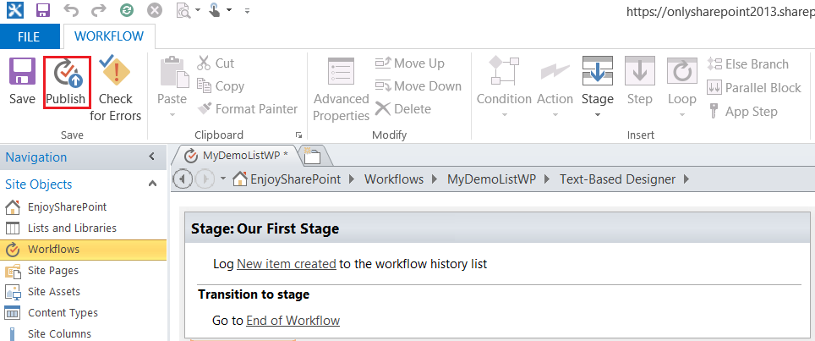

Now we can open the SharePoint site and then will add one item to see if our Log to History is working fine or now.

To check whether the workflow is successfully deployed to the list. Open the List in the browser and then from ribbon click on Workflow Settings like below:

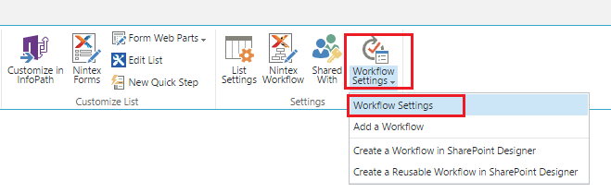

This will open the Workflow Settings page there you can see the workflow will be there like below:

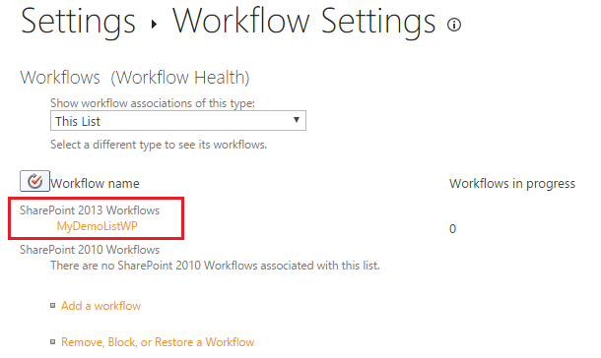

Since the workflow is start option is set as start the workflow manually as well as well as when the item is added, it should trigger when user add an item to the list.

I created one item like below:

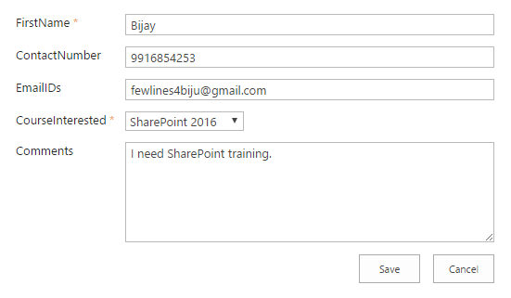

Now you can see our workflow link with our stage name.

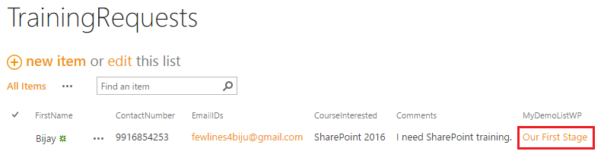

This will open the workflow and you can see the workflow details like below. It will also show the Workflow History and it will the message we have put in it.

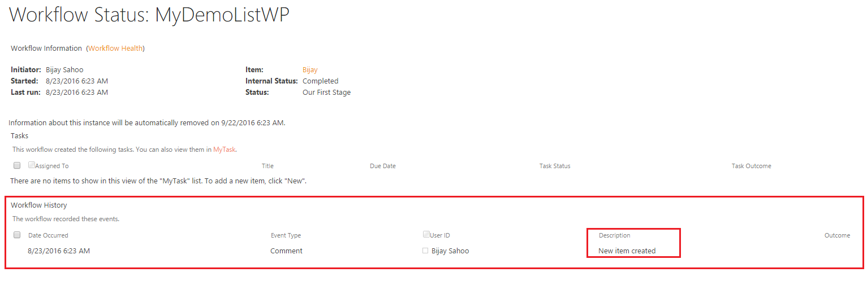

## Modify the Log to History to put Item Title:

Then we will see how we can put item title in the Log to History.

Here click on … in the Log to workflow history like below:

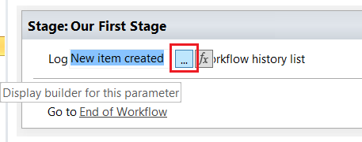

Then it will open the String Builder, Put the cursor after the string, and then click on Add or Change Lookup button like below:

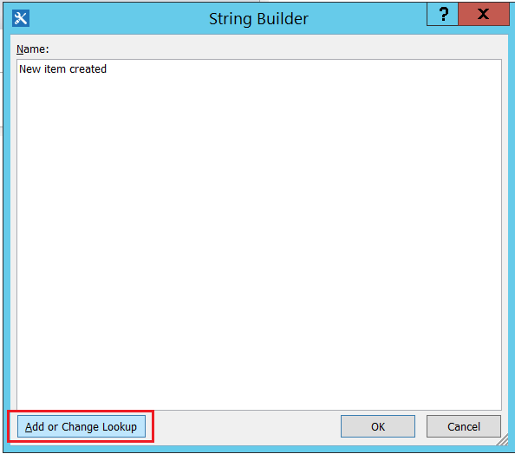

Then it will open the Lookup for String dialog box. Here choose

Data Source as Current Item

Field from source as FirstName column like below:

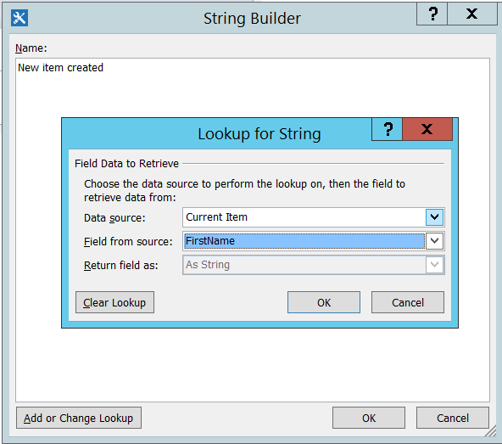

Then click on OK. Now the string looks like below:

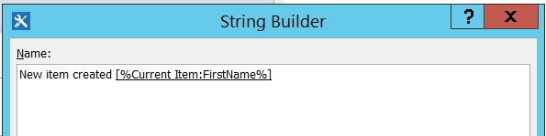

Then click on OK and the workflow now looks like below:

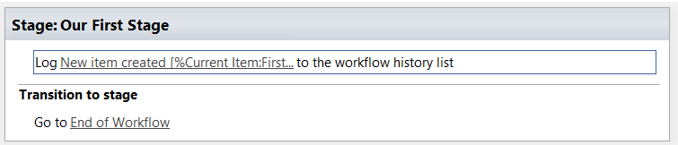

Now publish the workflow.

This time we will see how we can run the new workflow manually.

Go to the list and then click on the ECB menu (…) and then Advanced -> Workflows

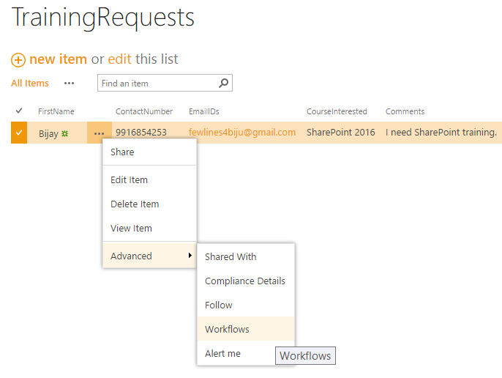

This will open the workflow settings page. Here click on the Workflow to start the workflow.

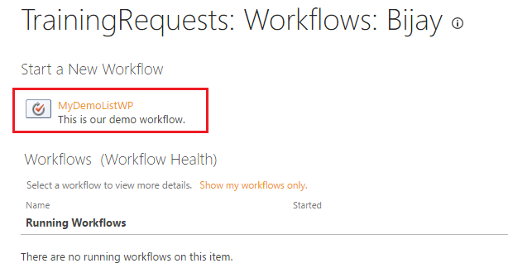

Once the workflow runs successfully. You can see the Description field in the Workflow History. It has been added the item title to the Description like below:

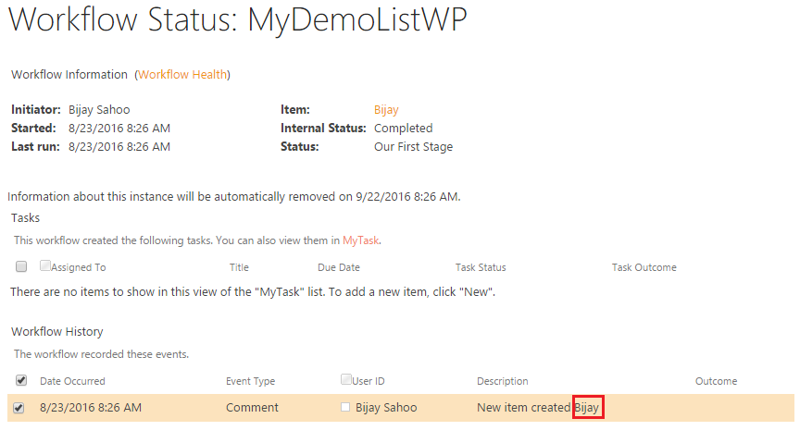

## Send an Email:

Here we will discuss how we can use Send an Email action in the same workflow. Here we will send a thanks email to the creator.

Edit the workflow which we have created above. Put the cursor down to the Log to History action and then from Action -> Send an email.

It will be like below:

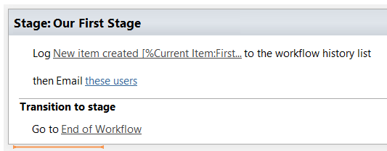

Now click on these users link. This will open the Define E-mail message dialog box like below. Where we can define the To, CC, Subject and Body like below:

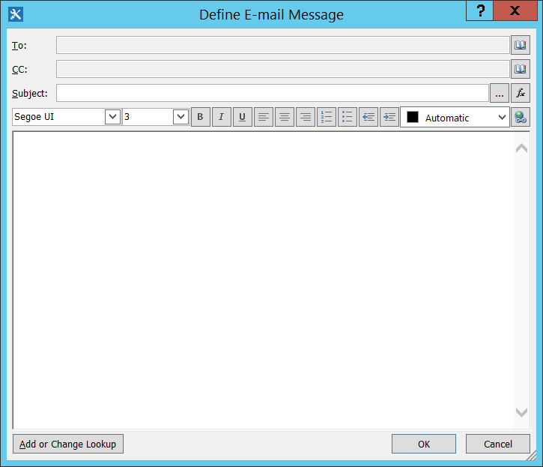

First click on the small book icon in the To field which will open the Select Users dialog box.

Here click on Workflow Lookup for a User... which will open the Lookup for Person or Group dialog box.

Here choose like below:

Data source: Current Item

Field from source: Created By

Return field as: Email Address like below. Then click on OK -> OK.

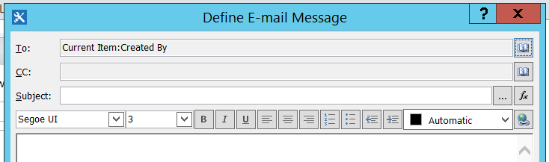

So the To field looks like above.

In the subject click on ... button and then choose

Data source: Curren Item

Field from source: FirstName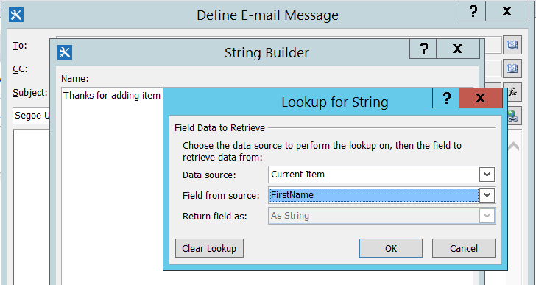

After this the Subject will looks like below:

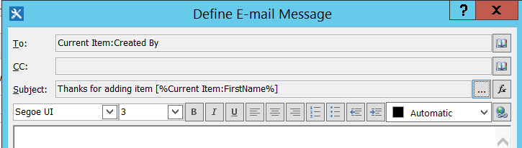

Now we will put the description part.

Write Thanks and then click on Add or Change Lookup. Then in the Lookup for String. Here

Data source: Current Item

Field from source: Created By

Return field as: Display Name

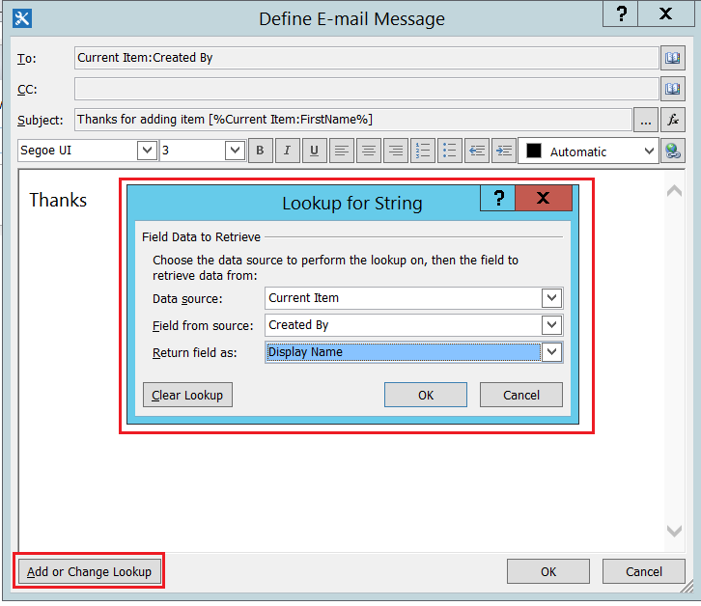

It will appear like below:

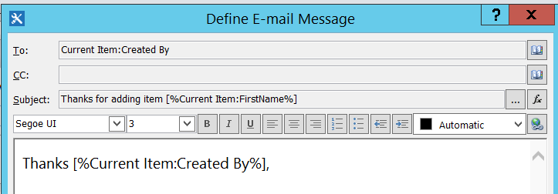

Then write like below:

For posting an item in the list.

Click here to open the item.

Here select Click here and then click on the hyper link in icon in the editor. Then in the Edit HyperLink dialog box:

Text to display: Click here

Address: First click on the fx button and then it will open the Lookup for String dialog box. Here choose like below:

Data Source: Workflow Context

Field from source: Current Item URL

Return field as: As String

It appears like below:

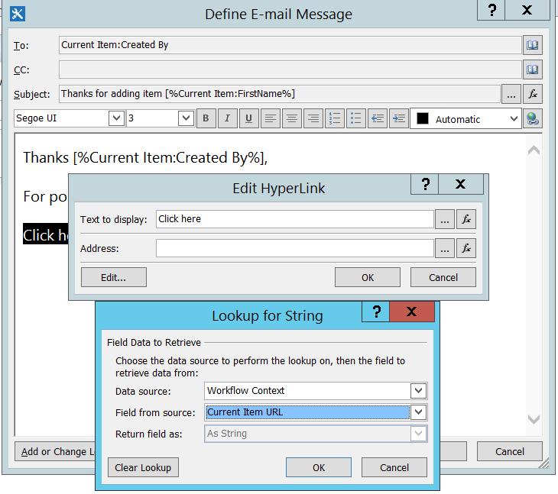

Now the email message dialog box will be like below:

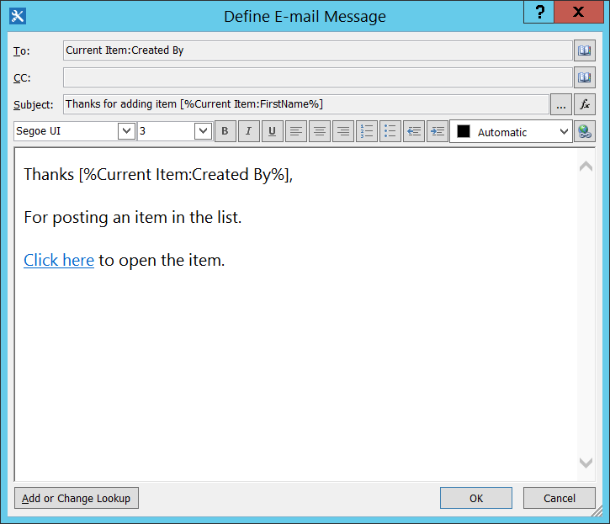

Now publish the workflow and try to create an item.

Once you will save an item, you can check your email and you will see an email like below:

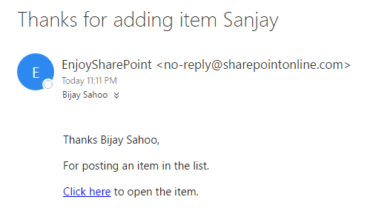

# Reusable Workflow SharePoint 2013

Here we will discuss how we can create a simple reusable workflow. Reusable workflows will be associated with a content type rather to any specific list or document library. Follow below steps to create a reusable workflow.

Open SharePoint designer 2013 -> File -> Open Site. Provide your on premise or office 365 site url. Then from the left side navigation click on Workflows and then from the ribbon click on Reusable workflow.

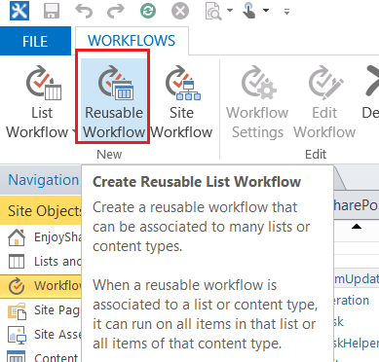

Then give a name for the workflow, description for the workflow and then choose the platform type as SharePoint 2013 Platform.

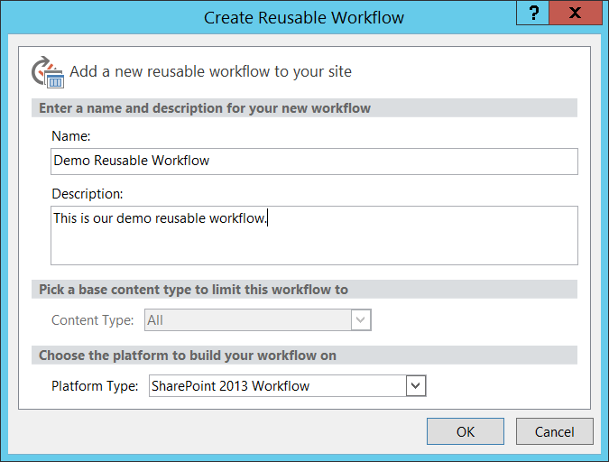

Once the workflow designer opens, you can rename the Stage like below:

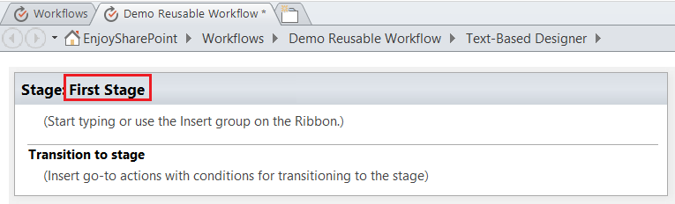

First we are going to write the Tranition Stage, Right click and choose “Go to a stage” and then choose End of Workflow.

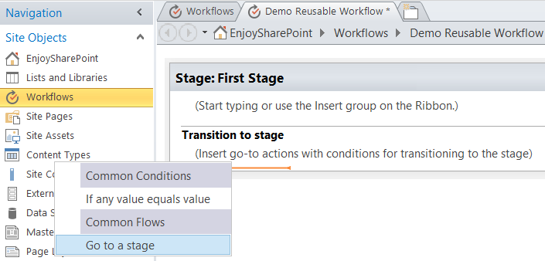

Here choose End of Workflow like below:

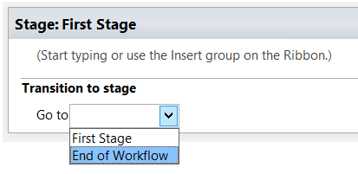

Then here we will simply write a message in Log to History list in our stage. Here I have added message like “Message from a Reusable workflow” like below:

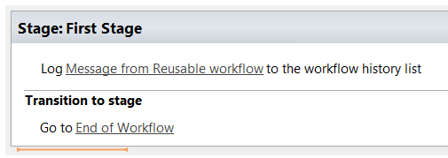

Now publish the workflow by clicking on the Publish button from the ribbon.

Once it is successfully published.

Now open your site and then open any list. Here I am going to an announcement list as “Training Announcements”. From the ribbon click on workflow -> workflow settings.

Here choose a content type (Announcement) like below. And then click on Add a workflow.

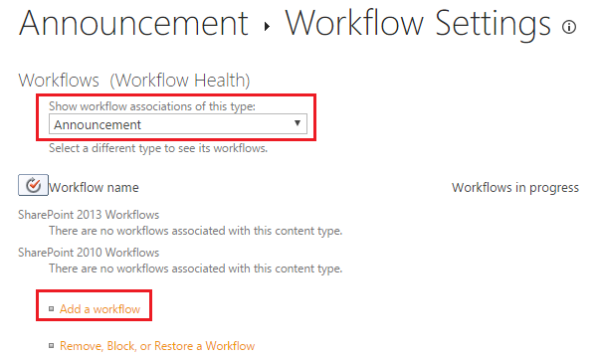

Then in the Workflow choose the reusable workflow which we have created in the above steps.

Then give a unique name for the workflow. Choose the task list, history list as well as choose the start option like below:

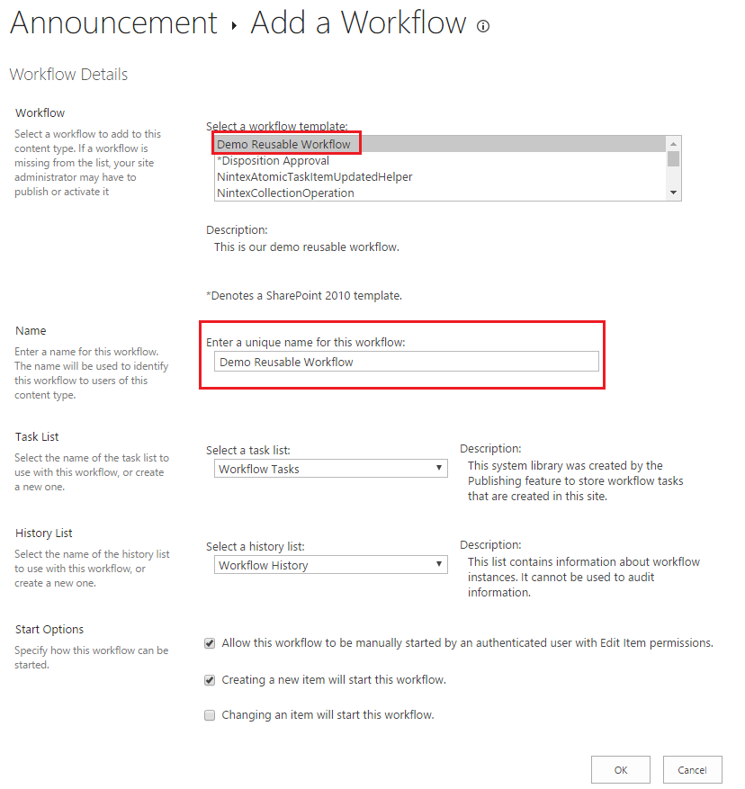

Now we will try to create an item to the list using the announcement content type. Then if you see the workflow status you can see the message which we have put inside the workflow.

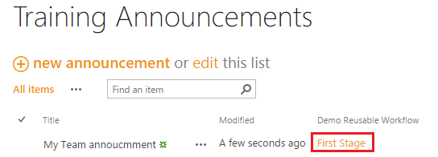

Click on the First Stage to see the details about the workflow which looks like below:

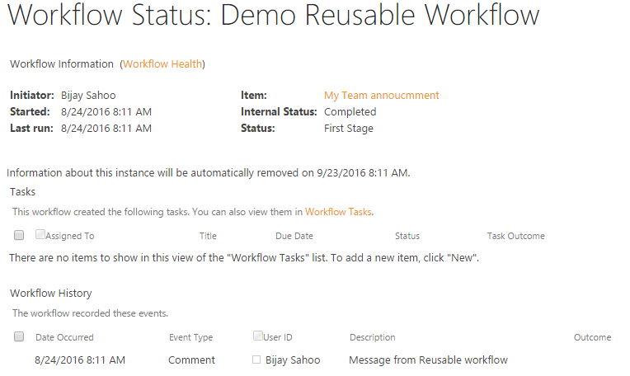

This end a sample on reusable workflow.

# SharePoint Designer Workflow Examples:

SharePoint designer workflows: Create your First Workflow using SharePoint designer 2013 <https://www.sharepointsky.com/sharepoint-designer-workflows/>

SharePoint designer workflow examples : Steps to create a Leave Request SharePoint designer workflow in SharePoint Online <https://www.sharepointsky.com/sharepoint-designer-workflow-examples/>

Deploy sharepoint 2013 designer workflow into production in SharePoint online <https://www.sharepointsky.com/deploy-sharepoint-2013-designer-workflow-production-sharepoint-online/>

SharePoint 2013 Workflow Impersonation step missing in Designer <https://www.sharepointsky.com/sharepoint-2013-workflow-impersonation-step-missing-in-designer/>

# Site Workflow (Create):

Go to SharePoint Designer and open your SharePoint Site. Now click on "workflows" which is inside Site Objects. Choose Site workflow from the ribbons,

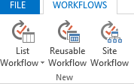

It will open the screen where you need to provide the **Name and Description** for the workflow and click ok.

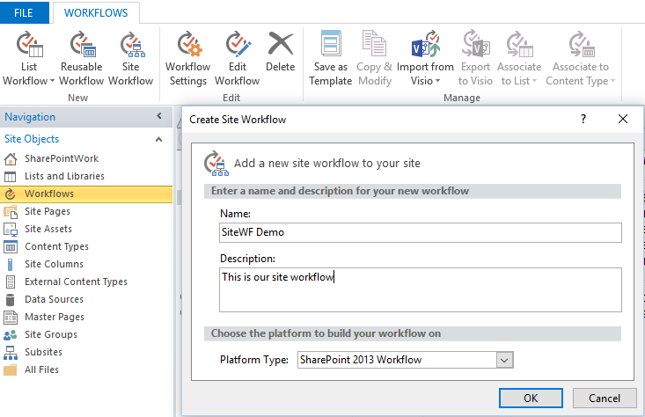

Once you click Ok, the workflow will get created. Now click on save button to save this workflow.

### Adding activities to the workflow:

When you saved your workflow, it will show **Stage 1** option from where you can start building the workflow. I have changed it to “WF”.

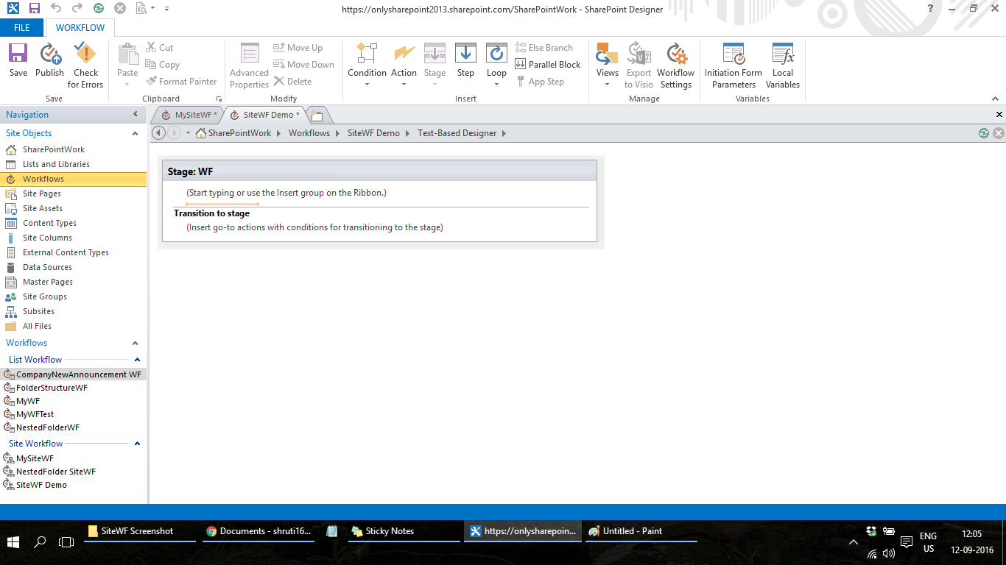

Go to action and Choose “Log to History List”

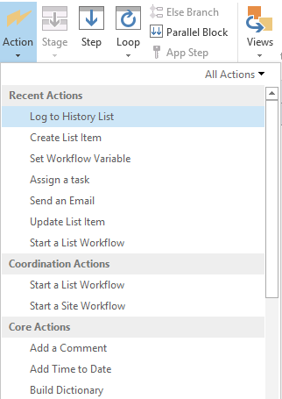

Here you have added an action "Log to History List" now your workflow is like below picture,

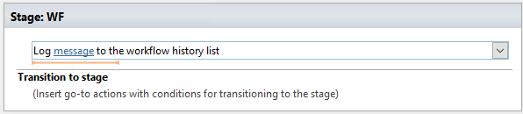

To add the logging information make changes in String builder and to add the user information, Type Hello.

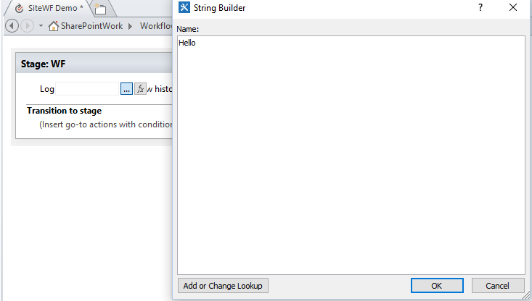

Then click on "Add or Change lookup". In the lookup for String choose details shown in the below screenshot and click Ok and Ok.

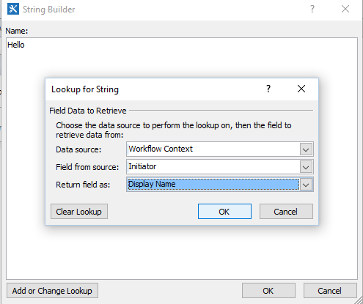

Once all things are done, you can see the below screen for "Log to workflow history action in designer.

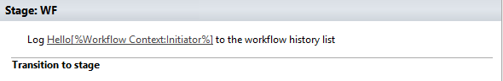

Now type go to stage inside Transition to stage. Click on stage and select End of Workflow.

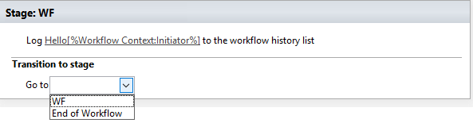

Now Save your Workflow and the Workflow will look like below picture,

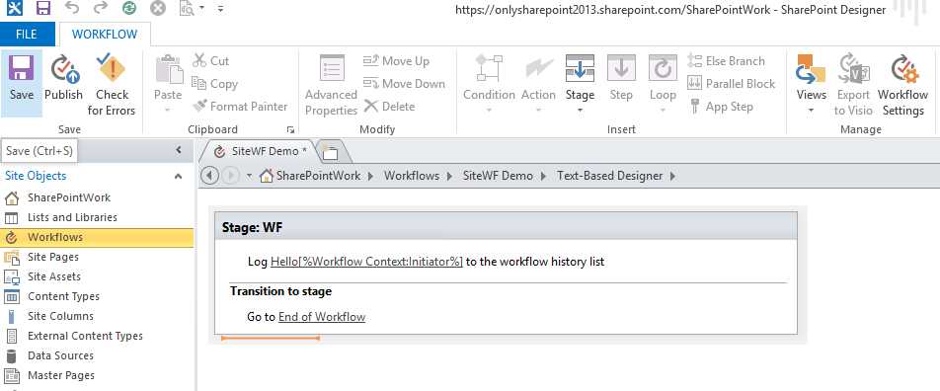

Check for Errors:

To check if there are any errors in the workflow, click on "Check for Errors" option.

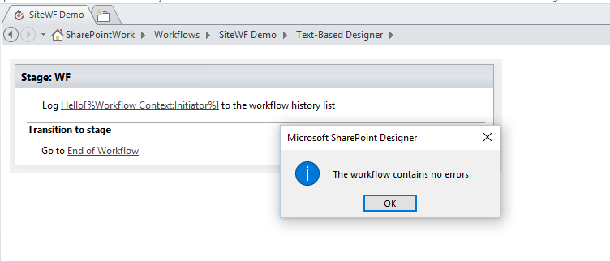

### Publish Workflow:

If everything is ok, then click on Publish button which will do "Save and Publish" operations. You can see the below status screen for publishing the workflow.

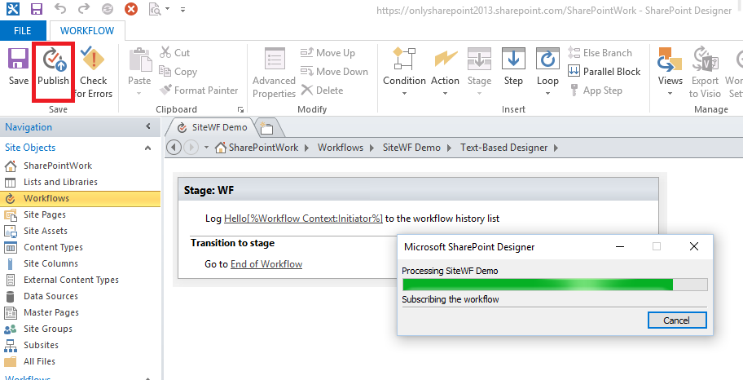

Finally the workflow has been saved and published to the site.

If you want to check where is your workflow, click on workflow, you can see the detail information about that in the below screenshot.

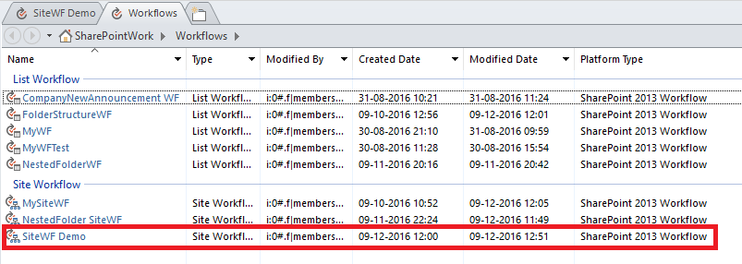

You can see the workflow settings page, It will look like this,

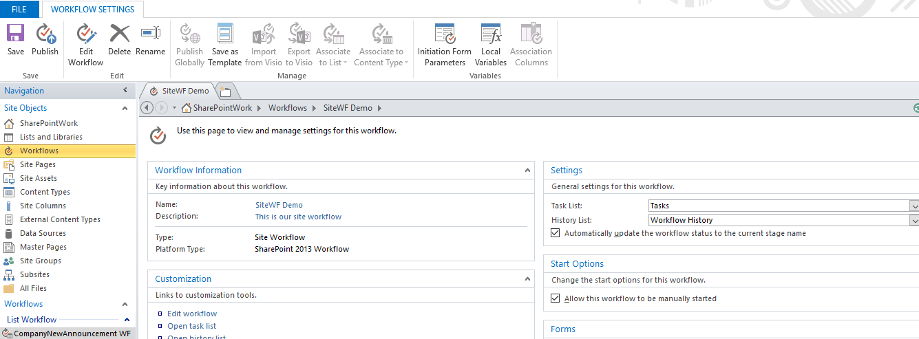

### Start Workflow:

To Start the workflow, go to Site Settings🡪 site contents then click on "**Site workflows**" .

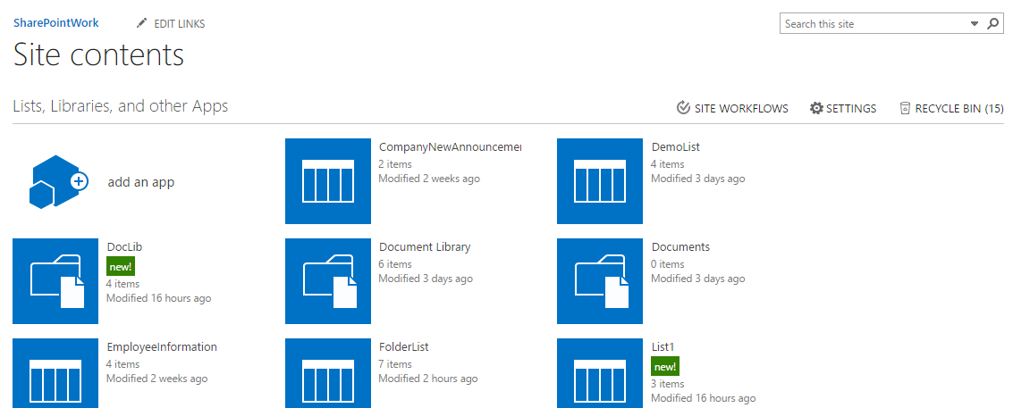

This will open all the workflows which have been deployed to that particular site.

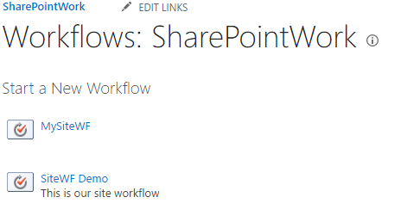

To start the workflow, click on "SiteWF Demo".

Once it started it will show the status as completed.

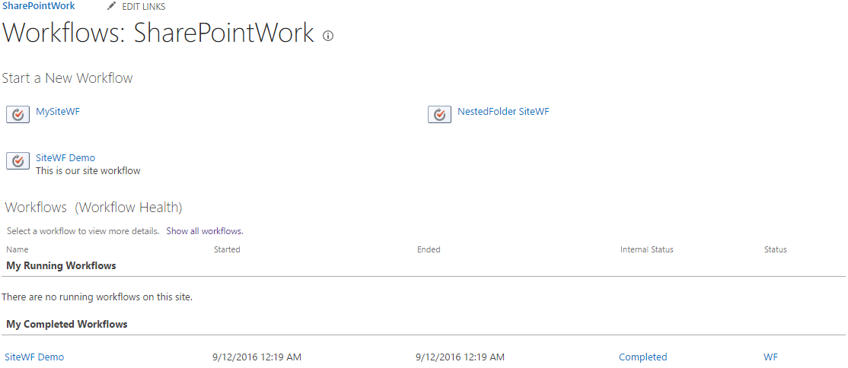

Click on the "Completed" status under "My completed workflows" section. You can see here the details of workflow history.

You can see in the below screen shot under workflow history. The action you have added in this example is log the initiator details, that you can see under "description".

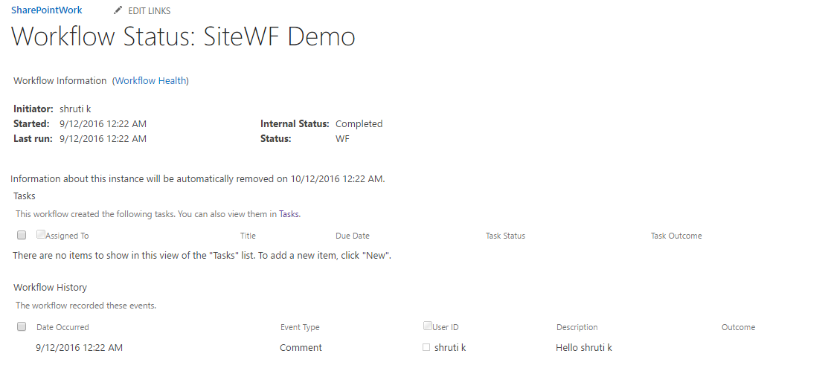

# Deploy Workflow to another Site collection:

Here we will discuss how we can deploy the designer workflow to another site collection in Office 365 SharePoint Online.

To deploy the workflow into another site, we need to first make sure that the destination site will have all the lists presented. And then we need to Save the workflow as template and then we need to upload into another site.

First we will Save the associated list as template. You can follow steps which we have explained before.

Then upload the list template to the other site collection.

Then we will create a new list using the same list template, make sure you give the same name as the source list name.

You can check in the Site Content that the site is successfully created.

Now open the source site in SharePoint designer 2013. Open the particular list, and from the ribbon click on Save as Template like below:

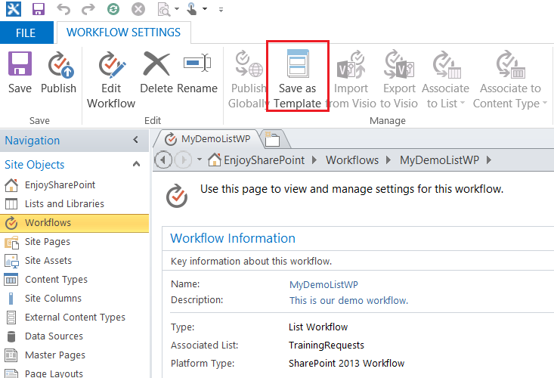

The template will be saved in the Site Assets library and it will show you a confirmation message like below.

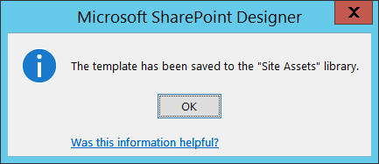

This file will be saved as a .wsp file. Either you can navigate to the site and then from the site assets library download the .wsp file. Or from the designer you can export the file and save it into some location.

Now open your destination SharePoint site and then go to Settings -> Site Settings.

In the site settings page, under web designer galleries and then click on Solutions. Now upload the wsp which we have saved in the local drive.

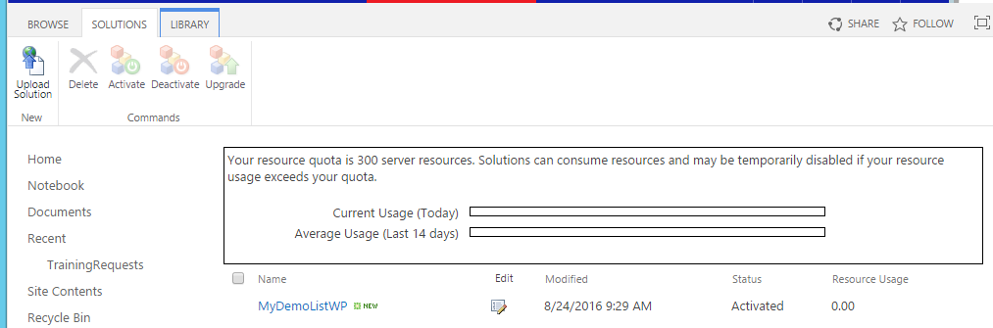

Now go to the site feature you can see a feature like below:



Activate the feature and check the workflow should be fine.

If you will open the destination site in designer, you can see the workflow like below.

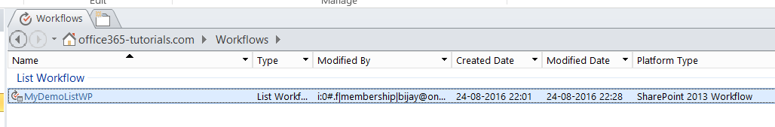

# Sequential Workflow:

- It looks very simple like flow chart.

- Steps within the workflow execute sequentially, one after another in the particular order.

- A sequential workflow always progresses forward, never going back to a previous step.

- Sequential workflows are definitely much easier to design and maintain.

# State machine Workflow:

- A sequential workflow executes in no particular order and these are based on events like OnTaskCreated, OnTaskDeleted etc.

- A sequential workflow moves from one state to another until the logic concludes the workflow has completed.

- Compared to Sequential workflows State machine workflows are difficult to design and maintain.

- In order to move to another event, the workflow needs to meet another state.

- The workflow doesn’t really have to end. It can stay in the same state for weeks.

# How to use Assign a task workflow action in SharePoint 2016/2013 designer workflow?

Now we will see how we can use assign a task workflow action inside a designer workflow. For this demo I have created a custom list using Announcement template in the SharePoint 2016 site.

Then I have added a custom column of type people picker to it (AnnoucementApprover). The list looks like below:

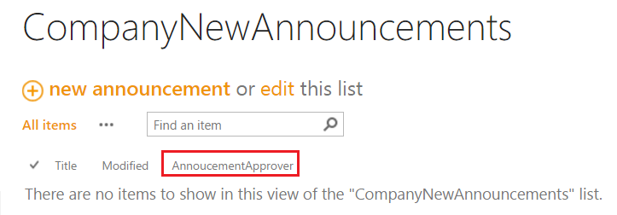

Now open SharePoint 2013 designer and create a list workflow for CompanyNewAnnouncements list.

First you can rename to a meaningful stage (“Approval Stage”).

Then from the workflow actions under Task Actions section select “Assign a task” workflow action like below:

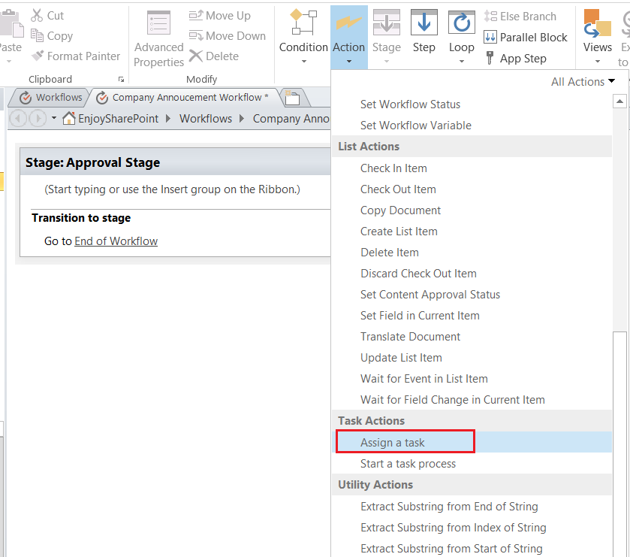

A task in SharePoint Server 2013 is used to assign work to a person or group and then track the progress of that work over time. There are two workflow actions in SharePoint Designer 2013 designed for working with tasks.

These actions are:

**Assign a task:** It is used to create a SharePoint 2013 task and assign it to a single participant.

**Start a task process:** It is used to assign a task to multiple participants.

The workflow action looks like below:

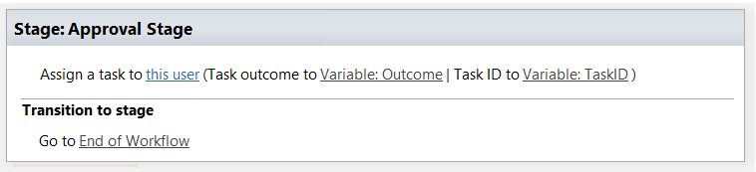

If you want to add workflow history list, you can add add like below:

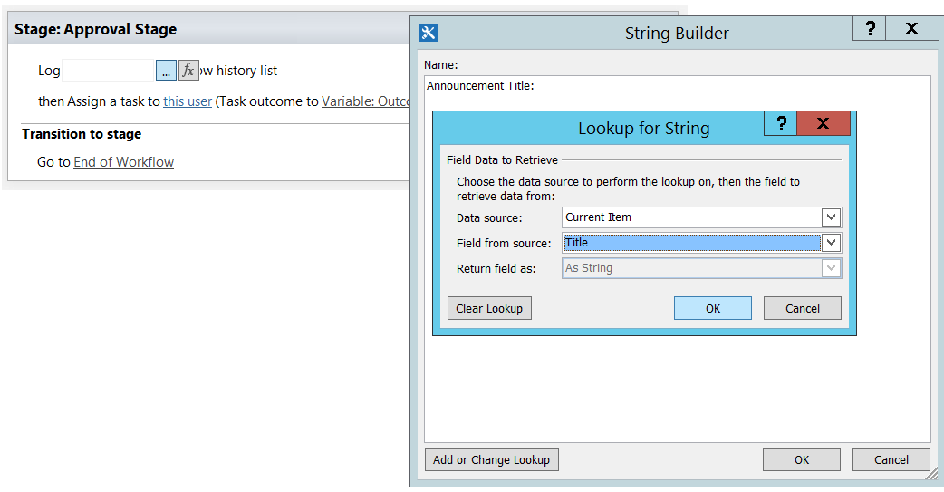

Now the full workflow can looks like below:

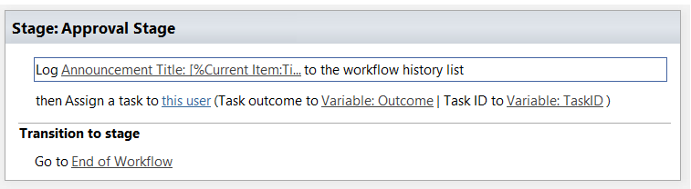

Now click on the “this user” link in the Assign a task workflow action.

Here we will assign the task to the Announcement Approver. Once you click it will open Assign a Task dialog box. There click on the … in Participant section. Then in the Select user dialog box, click on “Workflow Lookup for a user…” like below:

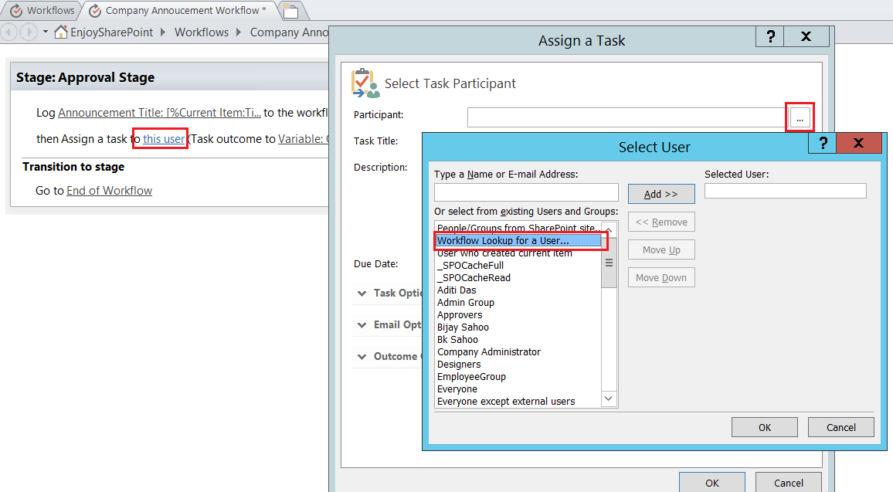

Once you click on Add >> button. It will open the “Lookup for Person or Group” dialog box. Here choose like below:

Data Source: Current Item

Field from Source: Select our column “AnnuncementApprover”

Return Field as: Email Address.

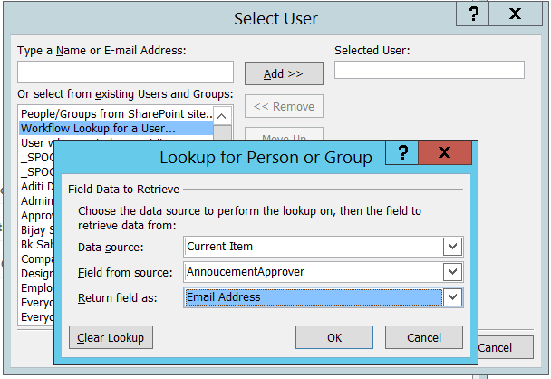

Then click on OK.

Then we will change the Task Title.

Here we will give a title like below:

New Announcement :: <Announcement name> added by <Created By>

Here click on the string builder. Then in the string builder for announcement name choose Current Item: Title and for Created by choose Current Item: Created By.

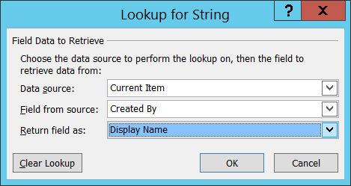

Your string builder like below:

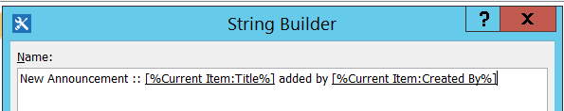

Now in the email option you can see the default email template which has been provided. The task template will looks like below:

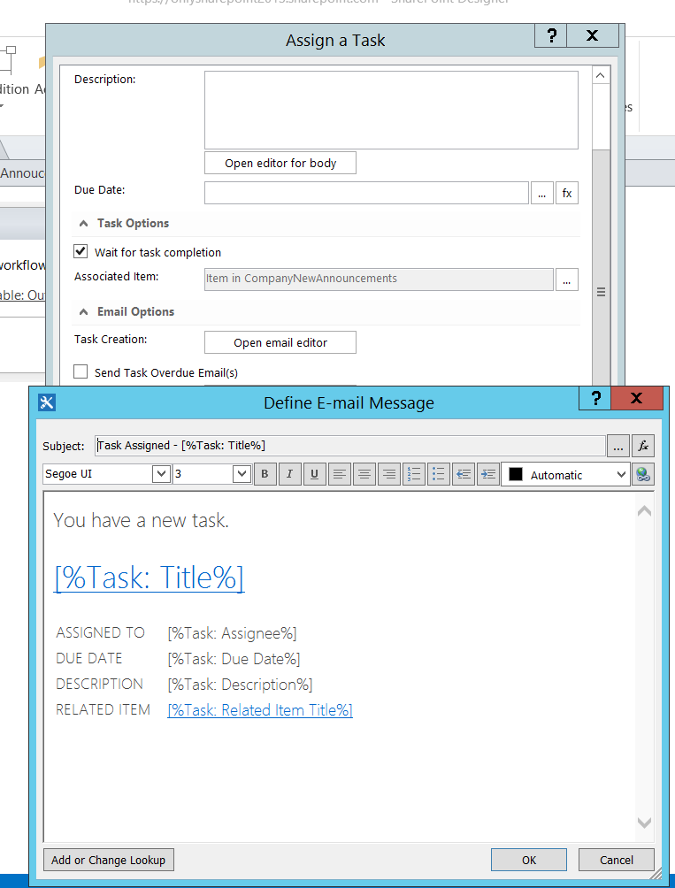

Now we will Log the task outcome in the workflow history list.

Click on the String builder and then choose the task outcome like below:

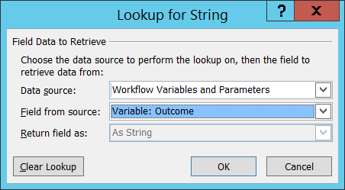

The task out come looks like below:

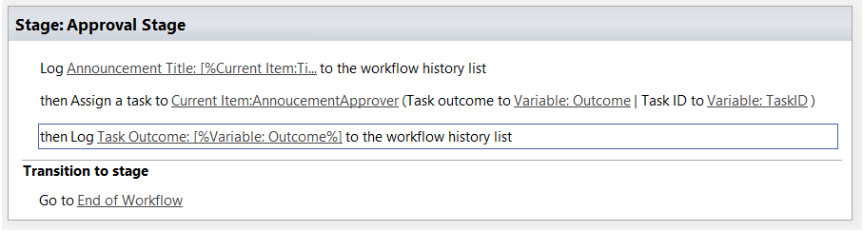

The we will see if the task approval is Approved or rejected and based on that we will send two emails.

Here we will add a condition like “If any value equals value”

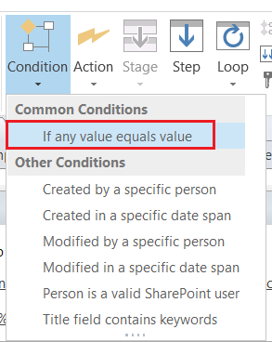

Click on value like and then choose the workflow variable.

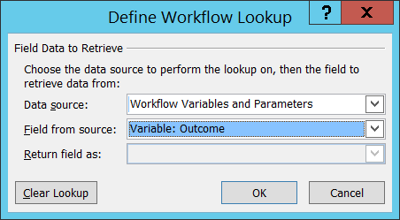

Then we will see if it is approved.

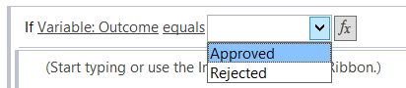

It looks like below:



Write an email to send the approval email.

Then write an Else branch and here we will send the rejected email. It looks like below:

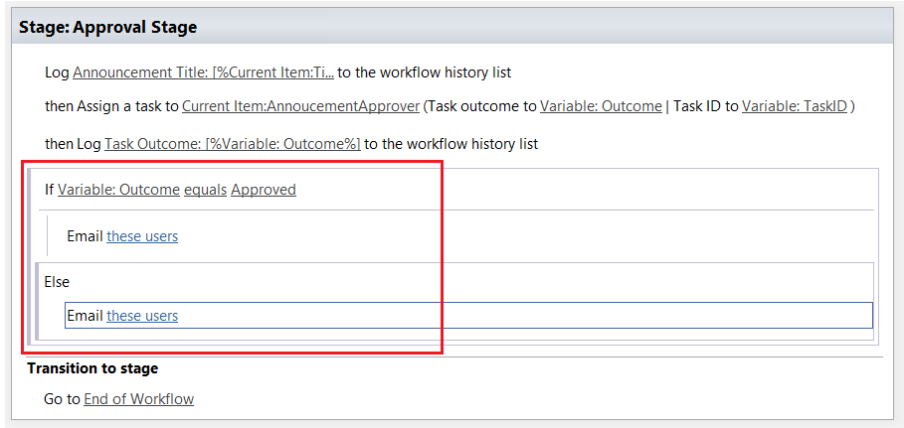

In the approved email we can write like below:

In the To field, Select User who created current item and click on Add.

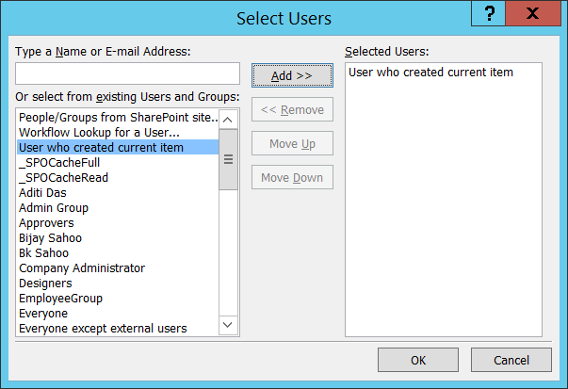

In the Subject we will add a meaningful title like:

<Announcement Title> Approved by <Approver>

The Subject looks like below:



For the Current User choose:

Current Item -> Created By and choose for Display name.

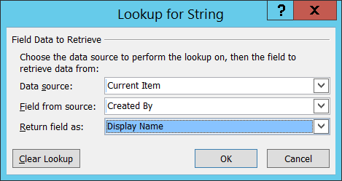

Now we will make the here as a hyper link.

Select here and then click on the hyper link.

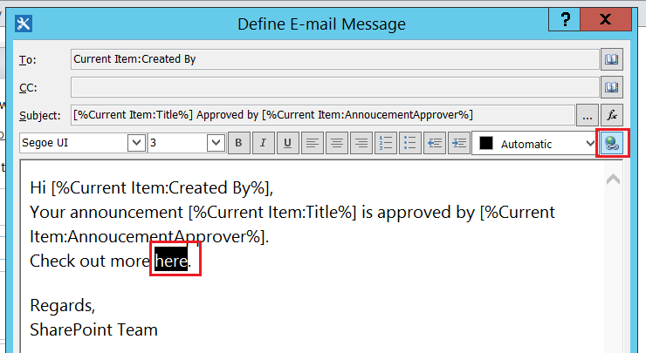

Then in the address, choose on fx then choose:

Data Source: Workflow Context

Field from Source: Current Item URL

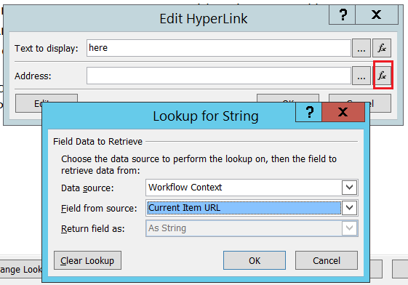

So the Edit HyperLink dialog box will looks like below:

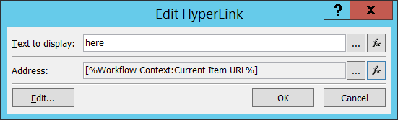

The Email message will looks like below:

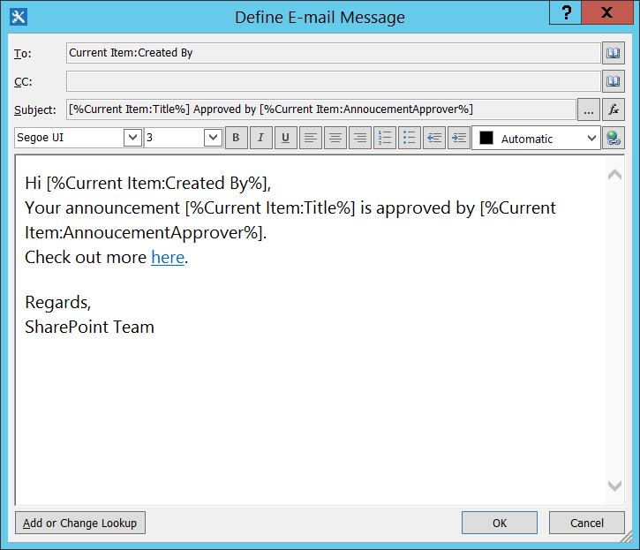

The rejected item email will looks like below:

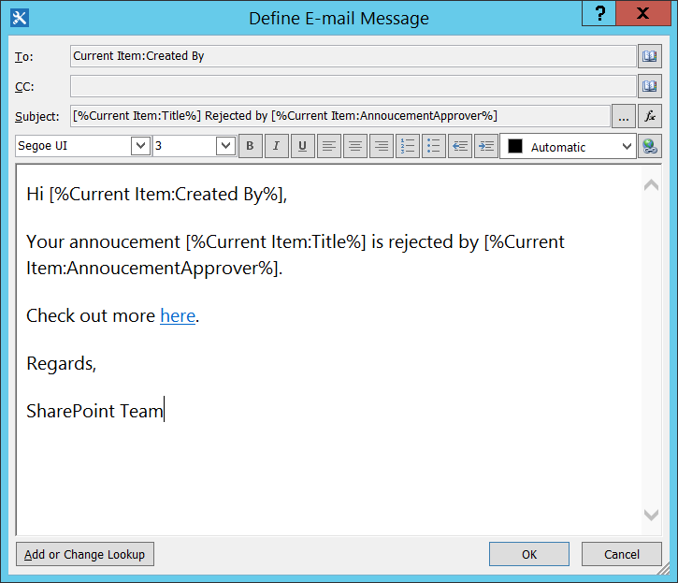

The whole workflow will looks like below:

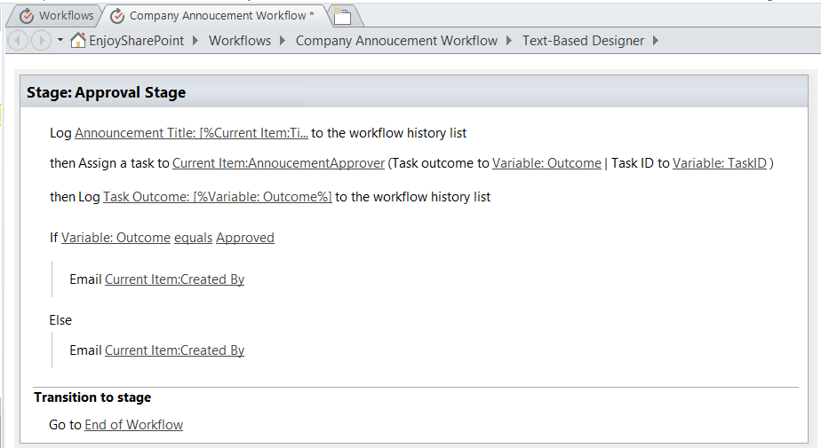

Now we can change the Start Option from the Workflow settings page.

Here we will choose the start workflow automatically created when an item is created.

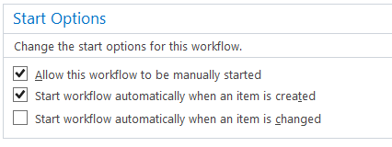

Now we have created and published the workflow. We will go to the list and try to add one item to the list.

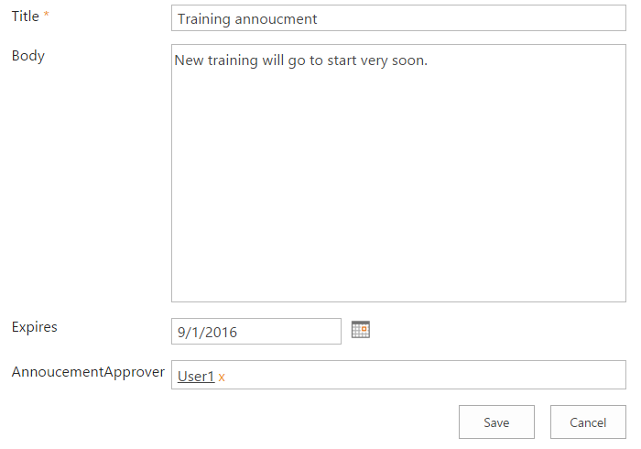

As you can see here we have put the user1 as the approver. User1 will receive an email to approve the task.

You can see the workflow is already started like below:

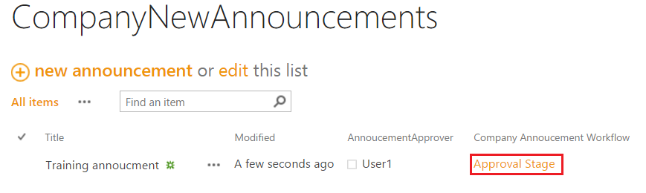

If you will check the email of the user1, you can see the email like below:

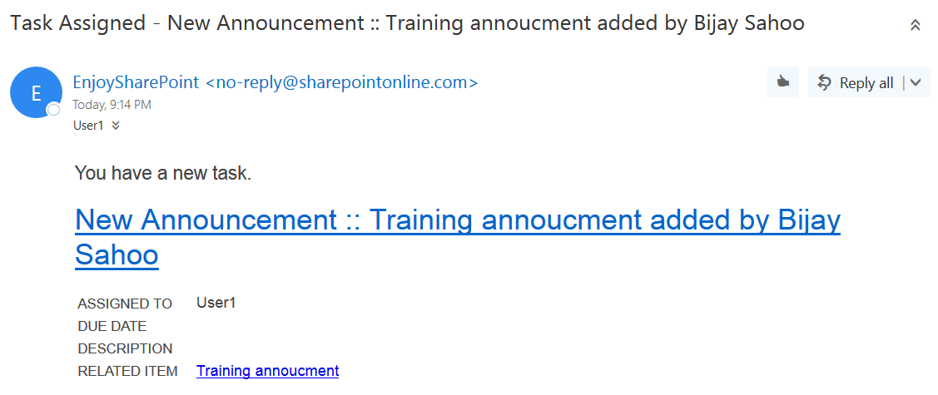

If you can see any task list you can see one task already created.



From the email you can click on task name which will open the list also which will open the task in the browser.

It will open the display list form, then you can click on Edit item which will open in the edit more.

Here click on the Approve button to Approve the task like below:

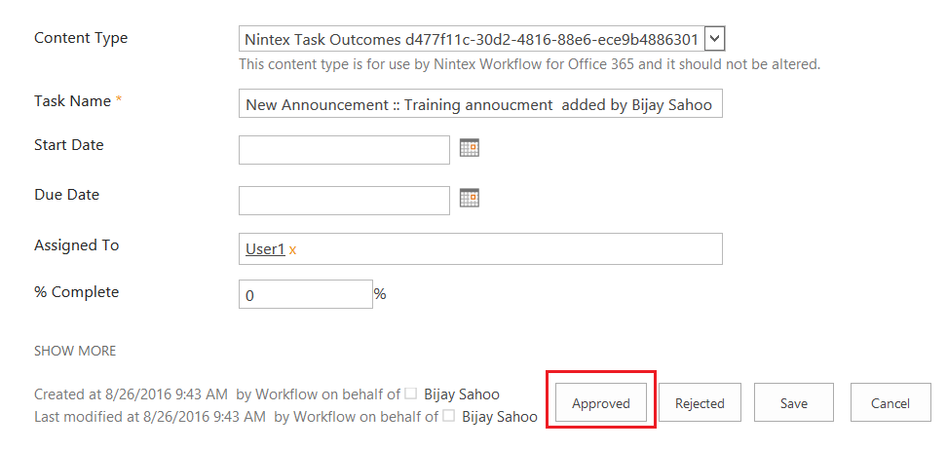

Once it is Approved. As per the workflow now the user should receive an approval email. You can see like below:

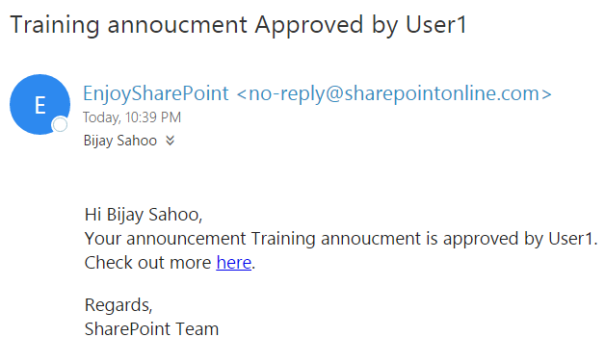

Similarly we can create another item and this time we will reject item. So the user will receive like below:

The rejected email looks like below:

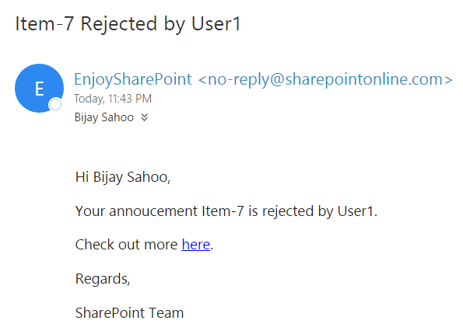

# Create a visual studio workflow for SharePoint 2016/2013

Step-1: Open visual studio click on new project-> choose “share point 2016 empty project”->Give the name as “MyWorkflowDemo” and click on “Ok”.

Step-2: From the below screen give ur SharePoint site url and choose “Deploy as a Farm solution” option and click on “Finish” button.

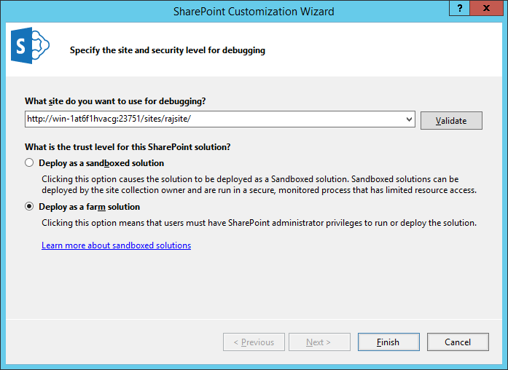

Now the Project structure will looks like below.

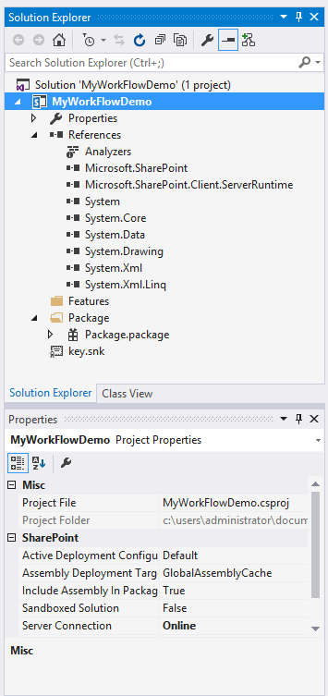

Now right click on the solution and click add->New Item

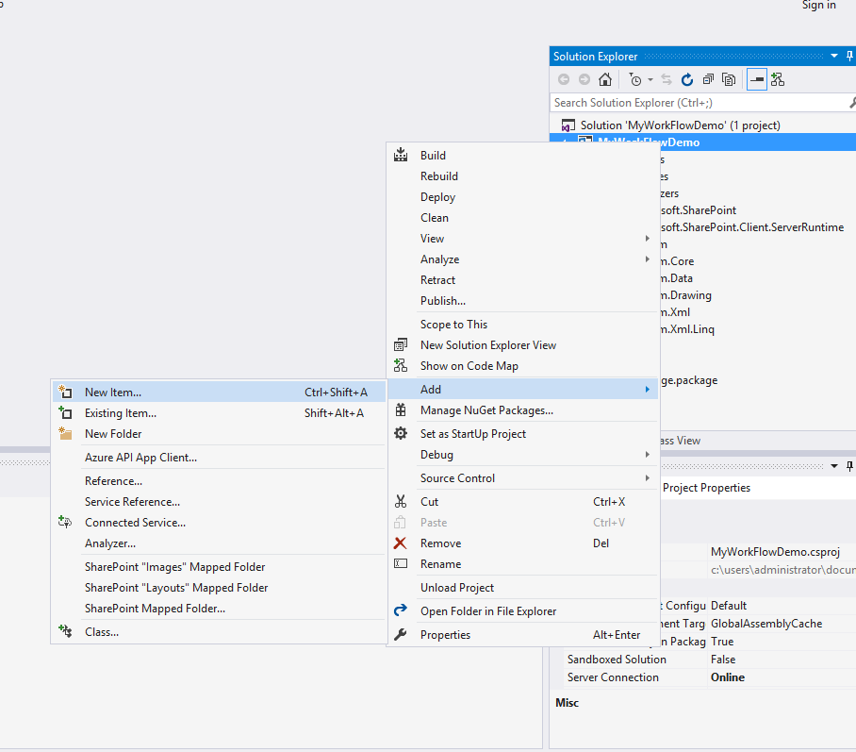

Now please select the template as “Workflow” and give the name as “LogonToHistory” and click “Add”.

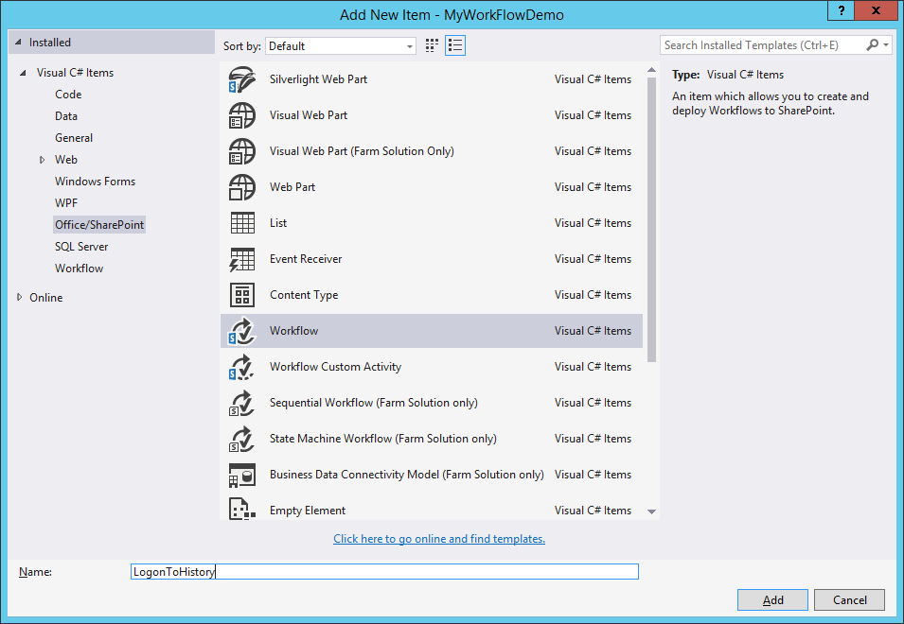

Choose the type of workflow as “List Workflow” and click on “Next”.

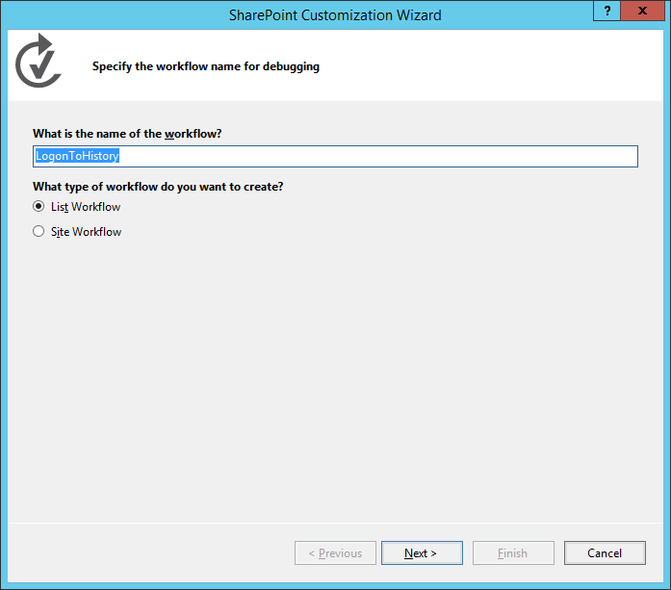

Choose the list for which you want the workflow to be triggered .In my case the list name is “Product”.The history list and task list you can choose as <Create New>.

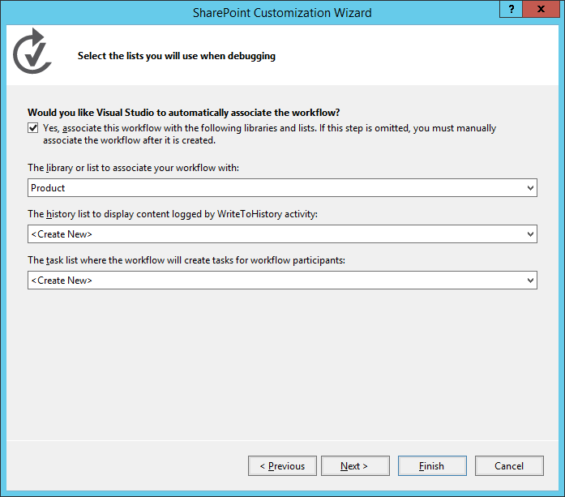

Now click on next and choose the below two options.

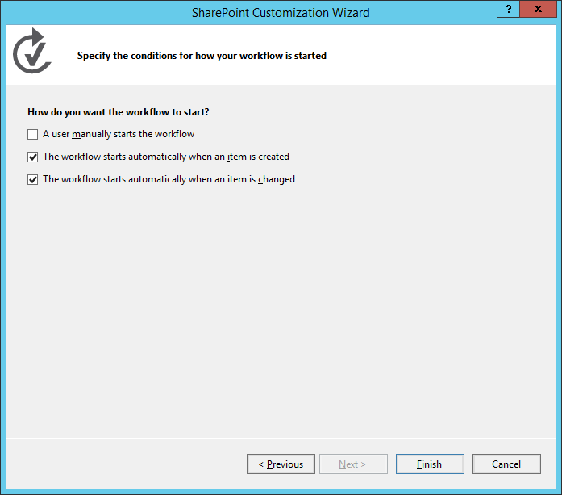

Now click on “Finish” button.

The below is the sharepoint list named as “Product” for which I want to triggered the workflow.

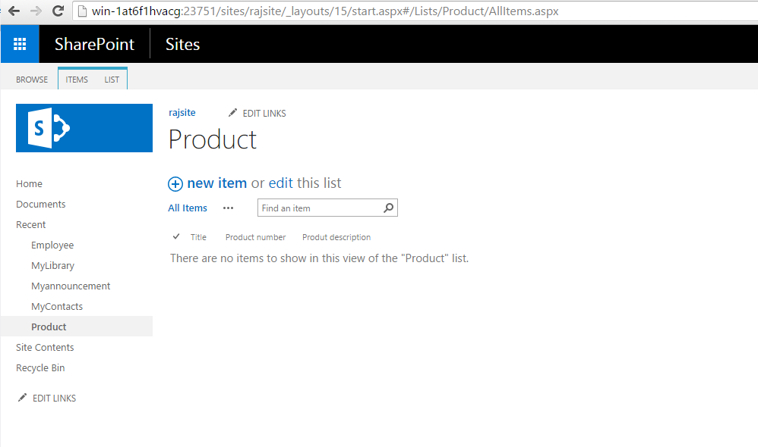

Now after you click on “Finish”, the project structure will looks like below.

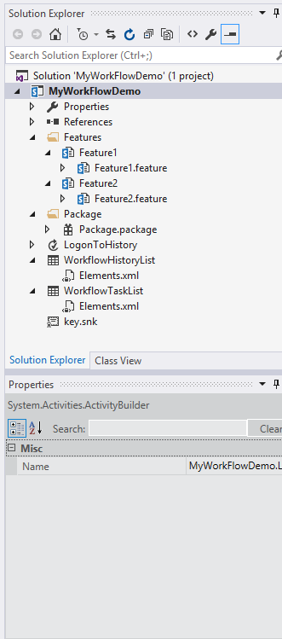

Now from the toolbox, drag the “WriteToHistory” activity and drop it on the “drop activity here” area.

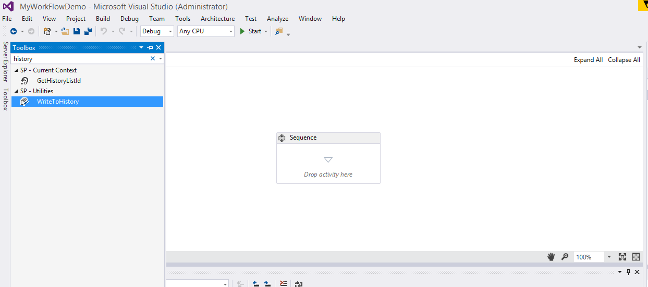

After drag and drop, It will look like below

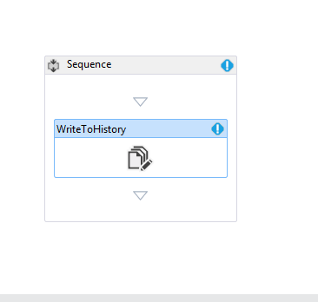

Right click and select “Properties”.

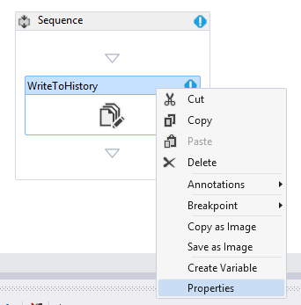

Now in the properties window set the message like “My new workflow”.

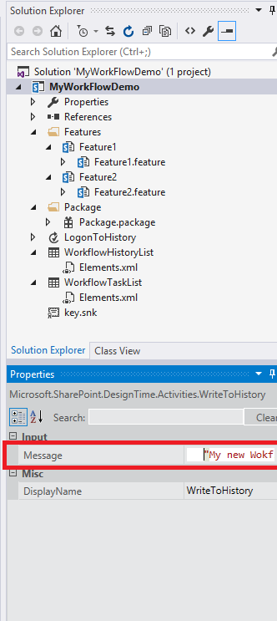

Now click on save all in visual studio.

The next step is right click on the solution and click on “Publish”.

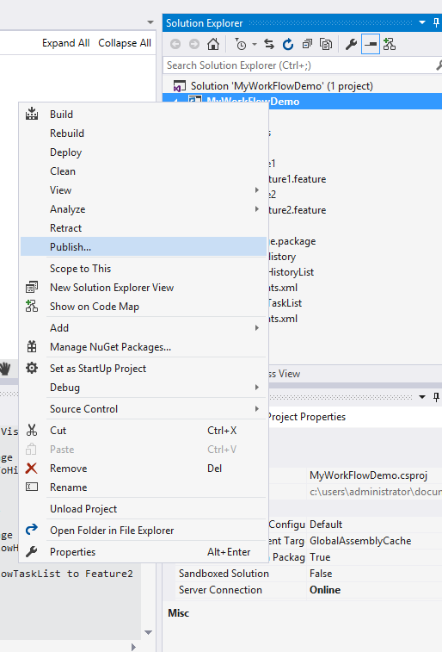

Now the below publish window will appear copy the path to a note pad and click on “Publish”.

In my case the default path is “C:\Users\Administrator\Documents”.

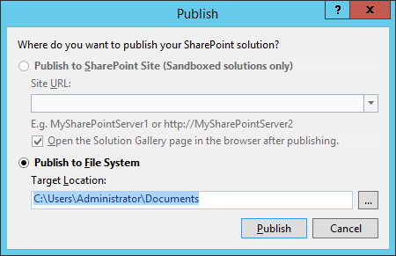

Now after it will succeed, check the same path you will find a wsp file in the same path.

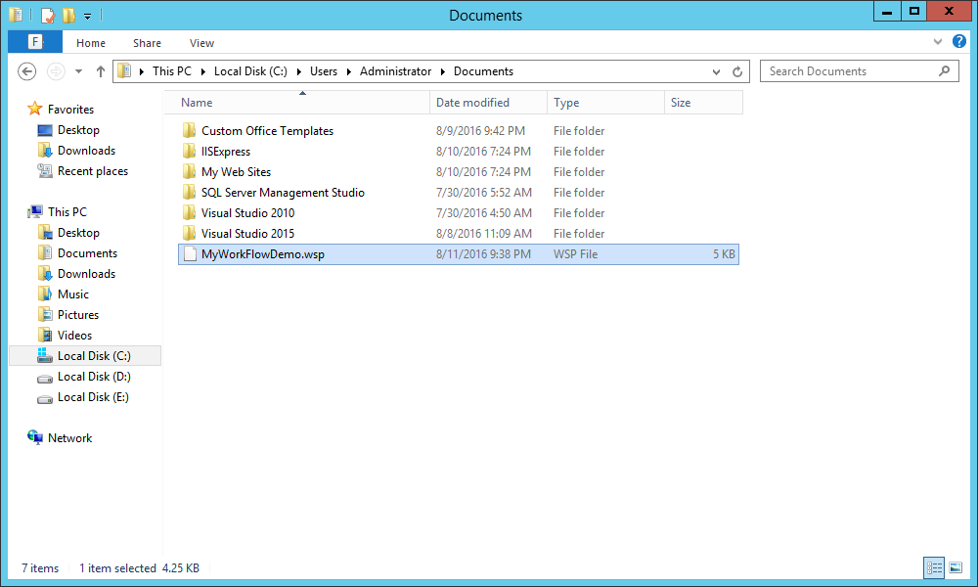

Now open your share point site and go to “site settings”

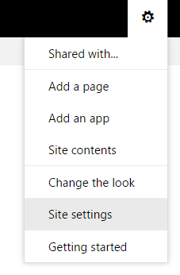

Choose solutions option from “Web Designer Galleries”.

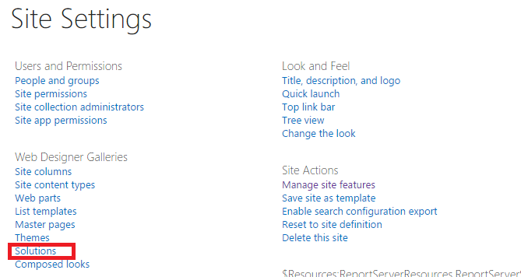

Click on upload solution.

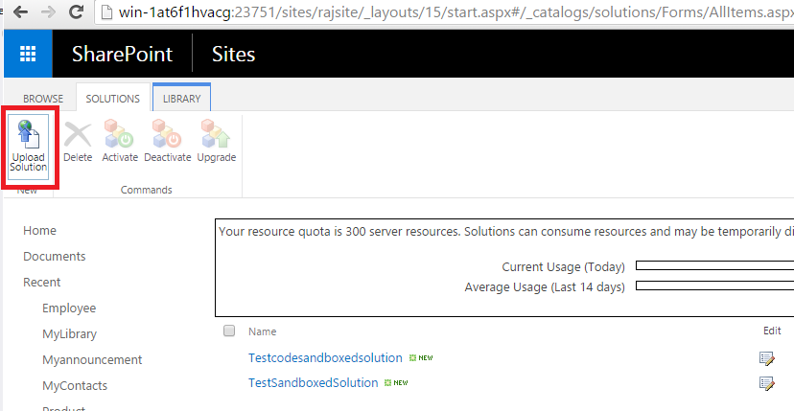

Browse and choose the same wsp which generated from the same location

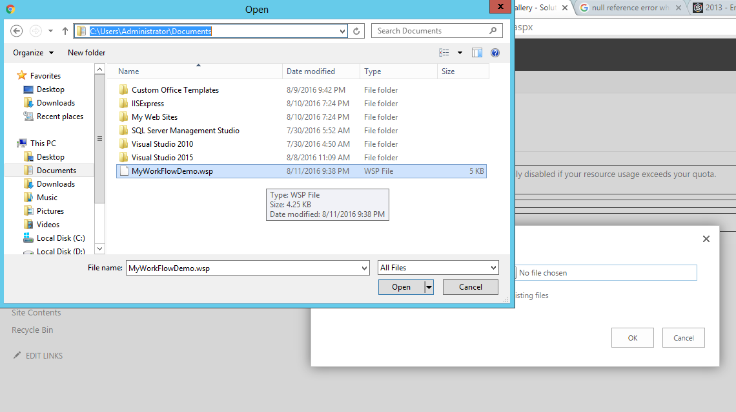

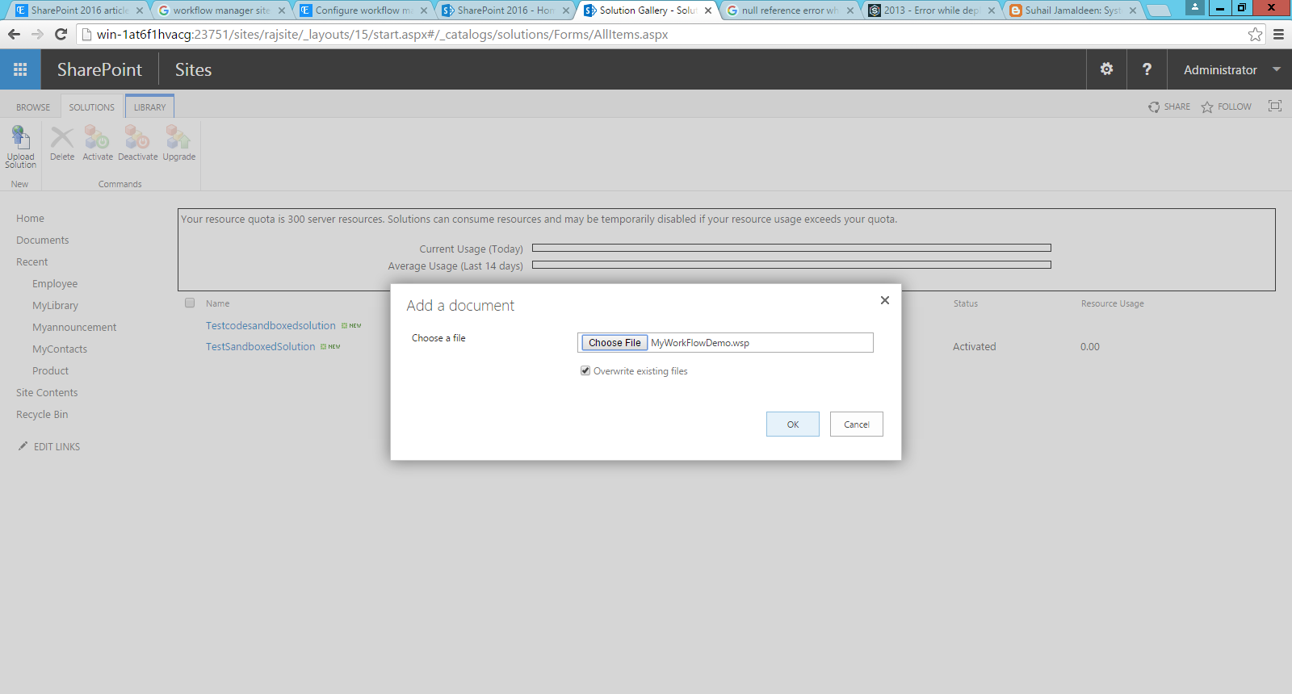

Open the same and click “OK”.

Now click on “activate” as below.

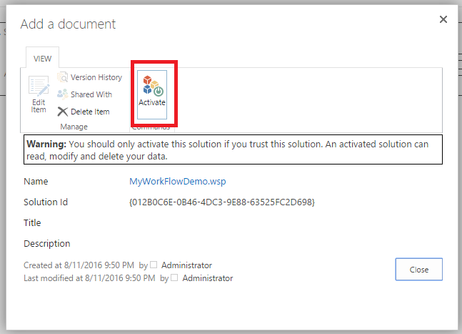

Now see the status of the solution is activated.

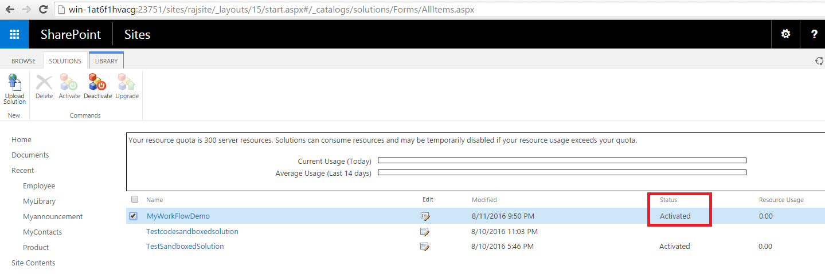

Now from visual studio right click on the solution and click Deploy solution.

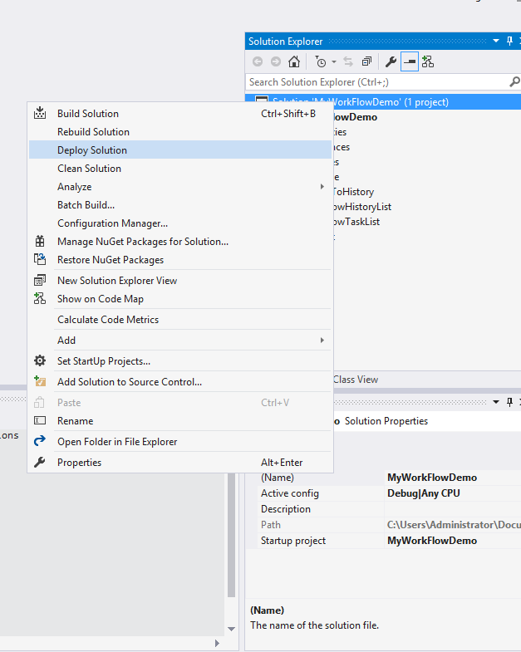

Now add one item to the Product list and go to the below option and click on the Workflows.

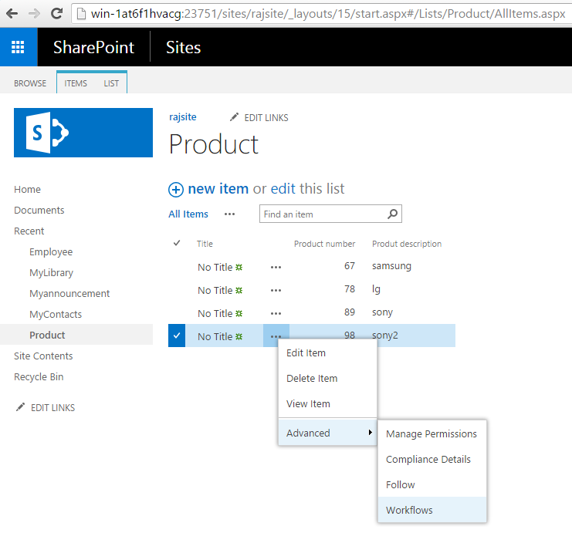

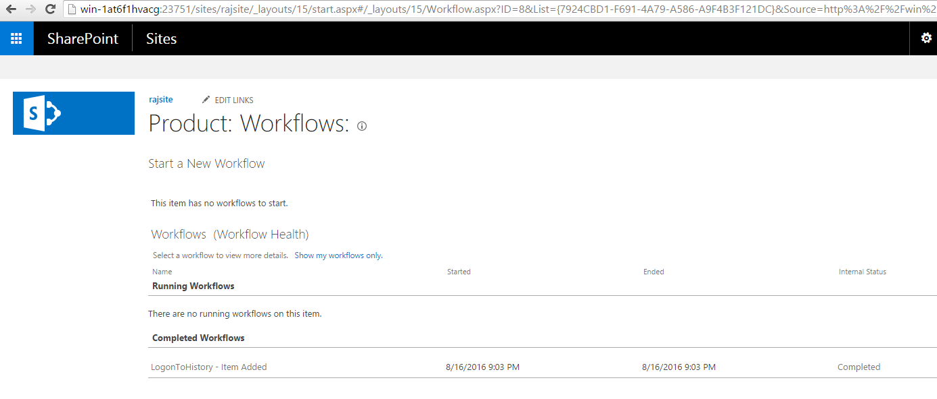

Now see the workflow with description as “My new workflow”.

